MODULAR GSM GPS TRACKING UNIT

ESKOM EXPO REPORT FILE

DANIEL WYKERD

STELLENBOSCH REGION

30 SEPTEMBER 2018

**Contents**

**Figure Index** 4

**Table Index** 5

**Introduction / Problem:** 6

**Engineering Goal:** 6

**Background Study on Required Components:** 7

The Microcontroller Unit (MCU) 7

The GSM/GPRS Module 8

The GPS Module 8

The SD Card 9

**Main Materials / Core Component list:** 9

**First Prototype of Core Module:** 10

1. Introduction and Materials Chosen 10

2. Testing the components 10

3. Schematic and Breadboard Layout: 12

4. Assembly 13

5. Software 14

6. Usage of The Device 15

7. System Diagram 16

8. Analysis of prototype: 17

Requirements 17

Criteria 18

**Second Prototype of Core Module:** 19

1. Introduction 19

2. Materials / Components Chosen 19

3. Cost 19

4. Replacing the Arduino with a Standalone MCU 19

5. Schematic and Breadboard Layout 21

6. Assembly 22

7. System diagram 24

8. Analysis of prototype 24

Requirements 24

Criteria 25

**Third Prototype of Core Module:** 26

1. Introduction 26

2. Choosing the Main Components: 26

3. Breakdown of Schematic 27

The GSM Module 27

The GPS Module 28

The MCU 30

4. Bill of Components (BOM) 31

5. PCB Layout 31

6. System Diagram 33

7. Case design 33

Design 1: 33

Design 2 35

8. Assembly 35

9. Software 37

10. Analysis of results 37

Requirements 37

Criteria 39

**First prototype of Datalogging Module:** 39

1. Introduction and Materials Chosen 39

2. Testing the components 40

3. Schematic and Breadboard Layout: 40

4. Assembly 42

5. Software 42

6. Usage of device 44

7. System diagram 44

8. Analysis of prototype: 45

Requirements 45

Criteria 46

**Second prototype of Datalogging module:** 47

1. Introduction 47

2. Choosing the Main Components 47

3. Breakdown of Schematic 48

The Power Management Circuit 48

The USB-to-TTL and Core Interface Circuit 49

The SD Card Datalogger 50

4. Bill of Components (BOM) 51

5. PCB Layout 51

6. System Diagram 53

7. Assembly 53

8. Software 55

9. Usage of the Device 55

10. Analysis of results 56

Requirements 56

Criteria 58

**Discussion** 59

Core module: 59

Datalogging, Power and USB interfacing module: 60

**Conclusion** 60

**Bibliography** 61

**Acknowledgments** 63

**Appendix A** 65

**Appendix B** 66

**Appendix C** 67

**Appendix D** 68

**Appendix E** 69

**Appendix F** 70

**Appendix G** 71

**Appendix H** 72

**Appendix I** 73

# **Figure Index**

Figure 1 Image of the main components (Wykerd, 2018) 10

Figure 2 Picture of Ultimate GPS Wiring for testing (Adafruit Industries, 2012) 11

Figure 3 Wiring of the SIM800L module to communicate with the computer (Wykerd, 2018) 11

Figure 4 Schematic of first prototype of core module (Wykerd, 2018) 12

Figure 5 Breadboard layout of first prototype of core module (Wykerd, 2018) 12

Figure 6 Image of breadboard assembly (Wykerd, 2018) 13

Figure 7 Example of the serial output (Wykerd, 2018) 15

Figure 8 Example of #Location SMS (Wykerd, 2018) 16

Figure 9 System Diagram of first prototype (Wykerd, 2018). 16

Figure 10 Arduino as ISP (Arduino, n.d.) 20

Figure 11 Atmega328p and 168 Arduino Pin Mapping (Arduino, n.d.) 21

Figure 12 Schematic of second prototype of core module (Wykerd, 2018) 22

Figure 13 Breadboard layout of second prototype of core module (Wykerd, 2018) 22

Figure 14 Final assembly of second prototype of core module (Wykerd, 2018) 23

Figure 15 System diagram of second prototype of core module (Wykerd, 2018) 24

Figure 16 GSM Section of Schematic (Wykerd, 2018) 28

Figure 17 GPS Section of Schematic (Wykerd, 2018) 29

Figure 18 MCU Section of schematic (Wykerd, 2018) 30

Figure 19 Top Layer of PCB (Wykerd, 2018) 31

Figure 20 Bottom Layer PCB Layout (Wykerd, 2018) 32

Figure 21 PCB Layout (Wykerd, 2018) 32

Figure 22 System Diagram of final prototype (Wykerd, 2018) 33

Figure 23 Top view of case (Wykerd, 2018) 33

Figure 24 Right view of case (Wykerd, 2018) 34

Figure 25 Front view of case 34

Figure 26 Dimensions of Top view of case (Wykerd, 2018) 34

Figure 27 Faulty board 36

Figure 28 Bottom of Assembled PCB 36

Figure 29 Top of Assembled PCB 36

Figure 30 Programming Station 37

Figure 31 Image of main components (Wykerd, 2018) 40

Figure 32 Breadboard layout of first prototype of datalogger (Wykerd, 2018) 41

Figure 33 Schematic of first prototype of datalogger (Wykerd, 2018) 41

Figure 34 Assembly of the first datalogger prototype (Wykerd, 2018) 42

Figure 35 System diagram of datalogger first prototype (Wykerd, 2018) 44

Figure 36 Power Management section of Schematic (Wykerd, 2018) 48

Figure 37 USB-to-TTL section of schematic (Wykerd, 2018) 49

Figure 38 Top Layer PCB Layout (Wykerd, 2018) 52

Figure 39 Bottom Layer PCB Layout (Wykerd, 2018) 52

Figure 40 Assembly Layout of datalogger (Wykerd, 2018) 53

Figure 41 System diagram of second datalogging prototype (Wykerd, 2018) 53

Figure 42 Complete assembled PCB of datalogger (Wykerd, 2018) 54

Figure 43 Burning bootloader to datalogger (Wykerd, 2018) 54

Figure 44 Programming the datalogger's MCU (Wykerd, 2018) 55

Figure 45 Datalogger connected to core module (Wykerd, 2018) 56

# **Table Index**

Table 1 List of possible components: 9

Table 2 Analysis of first prototype to design criteria: 18

Table 3 Analysis of second prototype to design criteria 25

Table 4 BOM of third prototype 31

Table 5 Analysis of third prototype of core module to design criteria 39

Table 6 Analysis of first prototype of datalogger to design criteria: 46

Table 7 BOM of datalogger second prototype 51

Table 8 Analysis of second prototype of datalogger to design criteria 58

Table 9 Total cost of project 65

# **Introduction / Problem:**

A need was identified in our country for a way to retrieve stolen goods especially vehicles like cars, motorcycles, and bicycles as well as personal property.

This project will attempt to solve this problem by designing and manufacturing a modular GPS module.

The need for this device is substantiated by multiple local governmental statistical releases. In a recent document published by the South African Police Service (SAPS) it is revealed there are 53 307 cases of car and motorcycle theft and 16 717 cases of car hijacking between April 2016 and March 2017 (South African Police Service, n.d.). It is also revealed in a statistical release done by Stats SA that there were 21 051 cases of bicycle theft, 284 252 cases of money/purse/wallet theft, and 18 119 cases of bag theft in this period. (Stats SA, 2017).

During the literature study to motivate the project several pre-existing products that prevent some of these problems by using GPS Tracking or alarm systems were identified, but most of these products are dedicated devices designed to only prevent the theft of one of the above-listed items. Research done on these devices can be found in the journal of this project. This project will attempt to design a GPS unit that can be used locate any kind of stolen goods. The device will not be limited to finding only certain objects.

There are devices like TrackingTheWorld’s ‘Enduro’ series trackers that are multipurpose (TrackTheWorld, n.d.), but most of these devices don’t offer any means to be hidden or attached, they are clunky, have a lot of unnecessary features, are uneconomical as they cost upwards of $289.00 and are not locally available to purchase. The device designed in this project will be customizable to suit the needs of the user and will be cheap to mass produce. The main device will have no unnecessary features and will be very small and compact.

# **Engineering Goal:**

The goal of this project is to ultimately design, test, produce and manufacture a modular electronic device that uses GPS to accurately track stolen objects from anywhere in the country. The reason for designing this device is to give users an easy way to retrieve lost or stolen goods by allowing the owner of the goods to view where their goods are located at all times. The device will be modular meaning that you can connect the core tracking module to different modules to add extra functionality and uses to the device to suit the user’s needs. The device/circuity should be as small as possible – preferably smaller than an AA-battery in length – and must be mass producible. The circuit should draw a low current as to prolong the device’s battery life. There should be no third-party involved in retrieving the coordinates thus the device should use common communication infrastructure like SMS to send the coordinates to the user.

In addition to designing, testing, producing and manufacturing a core device or module, a secondary module should also be designed, tested, produced and manufactured to demonstrate the modular nature of the device. In this case a data logging module will be created. This module should make use of a SD card to log the device's location for later viewing. This log should be preferably be stored in a common file format. The device should not consume a lot more battery power and should not add much more weight to the device.

# **Background Study on Required Components:**

To design the tracker and datalogging module, background knowledge of what components will be required to create the device was required. The required components were narrowed down to a microcontroller unit(MCU), which will be used to communicate with all the other components and process their data; a GSM/GPRS module, which will receive user queries (SMSs) and respond to them; a GPS module, which will get the location of the device; a SD card and slot, which will be used to store the data log on. This study will provide the reader with background knowledge on the integrated circuits and modules used in this project. It will also explain the reason behind choosing the components.

## The Microcontroller Unit (MCU)

A Microcontroller or MCU is a small computer contained on a single integrated circuit (IC). A microcontroller contains one or more processing cores along with memory and programmable input/output peripherals (Wikipedia, 2018).

The MCU will interface with all the other core components of the core device, including the GPS and GSM module. It will interpret user input from the GSM module, process the data from the GPS module and output code back to the GSM module to send the location of the device back to the user. The secondary datalogging module will also make use of a MCU to interface with and control all writing to the SD card.

There are plenty of microcontrollers on the market, but the decision was made to use an Arduino as the microcontroller (MCU) for the first prototype. This decision was made because the project leader (Daniel Wykerd) already had experience using Arduino and its IDE. Another deciding factor was the fact that Arduino is open source hardware. There was also decided to make use of an Atmel MCU with an Arduino bootloader burned on it for later prototypes as their MCUs are Arduino compatible. Research was done on multiple ATMega and ATTiny MCUs (all of which are listed in my journal) but there was decided that the ATMega328p MCU was the best option as it is the same MCU used in most Arduino boards, thereby making the design and testing process much easier as this MCU is very well documented online.

## The GSM/GPRS Module

The GSM Module is the part of the core device that will receive the user queries and will send back the response to the user. It uses a sim card and gsm antenna to connect to pre-existing mobile providers (e.g. Vodacom).

The prime requirement for the module is to be able to send and receive SMSs. Two companies were found during the study that makes modules that meet this requirement: Quectel and SIMCom. Both these companies were well documented, but further research into local availability revealed that Quectel was not readily available in the form of development boards (boards that already have all the support circuitry), thus SIMCom modules were chosen as they were widely available for purchase on development/breakout boards. It was necessary for the modules to be on breakout boards to create the first prototype on a breadboard for testing. There was decided on 3 possible modules: SIM808, SIM800L/H, SIM800C. The SIM808 seemed like a good choice as according to its datasheet it has GPS functionality built in, but it does not have an integrated patch antenna (SIMCom, 2016). The SIM800L/H was also considered as it is readily available on breakout boards and has all the features required and more, however this chip would not be usable for the final prototype as it comes in an LGA (Land Grid Array) package which can only be reflow soldered. Thus, it was considered to use the SIM800C in the final prototype. The SIM800C has less unnecessary features and more importantly, it has an easier to solder SMT layout.

## The GPS Module

According to Wikipedia.org, “The Global Positioning System (GPS), originally Navstar GPS, is a satellite-based radio navigation system owned by the United States government and operated by the United States Air Force. It is a global navigation satellite system that provides geolocation and time information to a GPS receiver anywhere on or near the Earth where there is an unobstructed line of sight to four or more GPS satellites. Obstacles such as mountains and buildings block the relatively weak GPS signals.” (Wikipedia, 2018).

There was decided on using the GlobalTop Technology Inc.’s FGPMMOPA6H GPS Module as it has an integrated patch antenna which will result in a smaller PCB footprint in the final prototype and fewer costs. The module is also used in Adafruit’s Ultimate GPS module and is well documented on their website. The module outputs its data as NMEA Sentences that can easily be read and interpreted by the MCU.

## The SD Card

SD or Secure Digital is a non-volatile memory card format that is most commonly used in portable devices. SD cards come in various sizes namely standard, mini and micro. It used NAND Flash memory to store the data.

The SD card will need to be slotted into a SD card slot that will most lightly be placed on the PCB of the datalogger. It will be used by the core tracking module to store data such as the logs.

There was decided to use a micro SD card slot and thus a micro SD card as it is small and has a reasonably large capacity (up to 32GB for the standard SDHC).

# **Main Materials / Core Component list:**

Below is a breakdown of the components that can possibly be used as well as their prices and what suppliers can be used to purchase them from:

Table 1 List of possible components:



# **First Prototype of Core Module:**

## Introduction and Materials Chosen

The goal of the first prototype was to test the concept of making a tracker and to ensure that all the picked components worked properly, thus the components were brought in the form of breakout boards for easy assembly.

Due to the time constraints of this project, the components for the first prototype had to be purchased locally. Thus, Communica was used as the supplier of parts for this prototype. A SIM800L breakout board and Ultimate GPS module (FGPMMOPA6H) module were purchased from them. An Arduino UNO was already purchased beforehand. A breadboard is also required for this prototype See Appendix A for the total cost of this project.

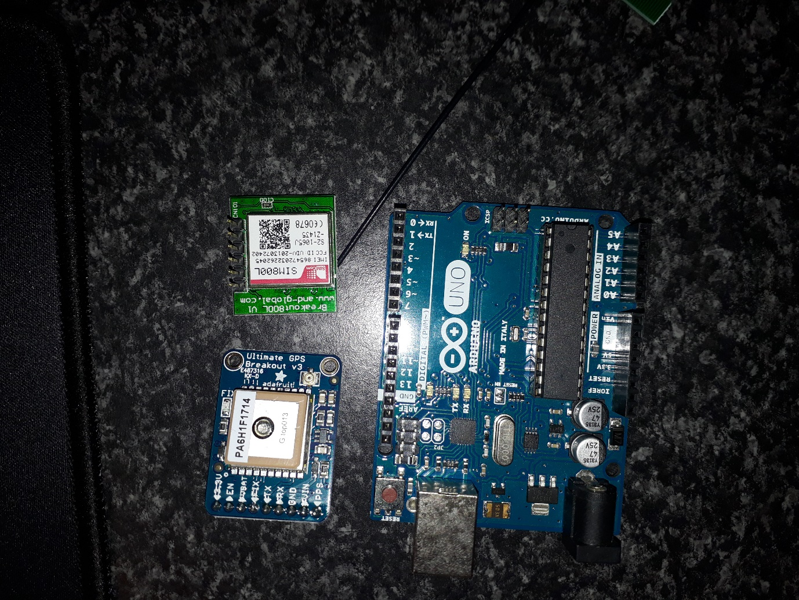

Figure 1 Image of the main components (Wykerd, 2018)

## Testing the components

Before creating the first prototype the components were tested to ensure that they were in working order.

To test the GPS Module, Adafruit’s provided example code and their provided code library found on their website was used. After installing the library found on their website (Adafruit Industries, 2012), the parsing example code which can be found in the project journal on the 20th of January 2018 was used. Below is an image of the wiring: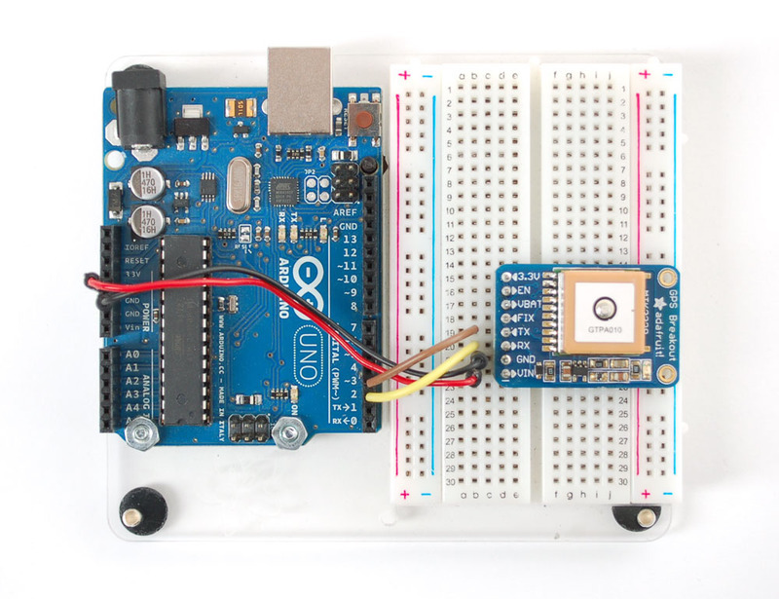

Figure 2 Picture of Ultimate GPS Wiring for testing (Adafruit Industries, 2012)

The test for the GPS was successful and the GPS gave accurate readings.

Next, the GSM module was tested via serial. It was wired like below:

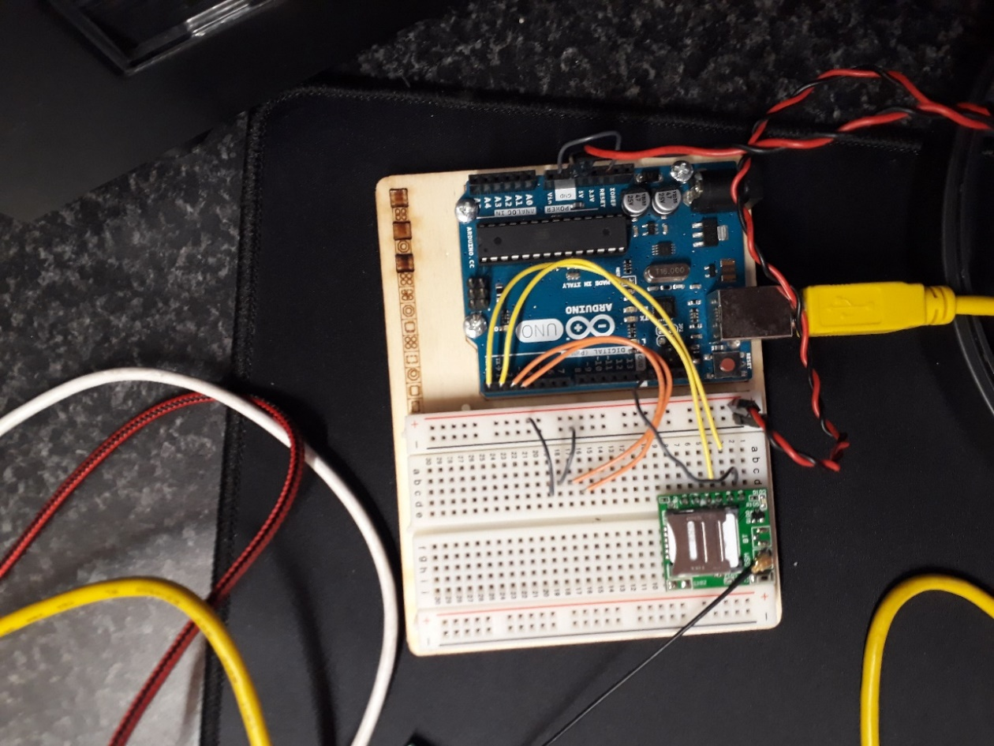

Figure 3 Wiring of the SIM800L module to communicate with the computer (Wykerd, 2018)

This test was also successful. However, the module could not acquire a network connection due to insufficient power. This was solved during the designing of the first prototype by adding a 3,7 V lithium-ion polymer (Li-Po) battery to power the module.

## Schematic and Breadboard Layout:

The following two figures show the design of the first prototype and was created using Fritzing, a free open-source software that allows you to digitally make your own schematic and breadboard layout.

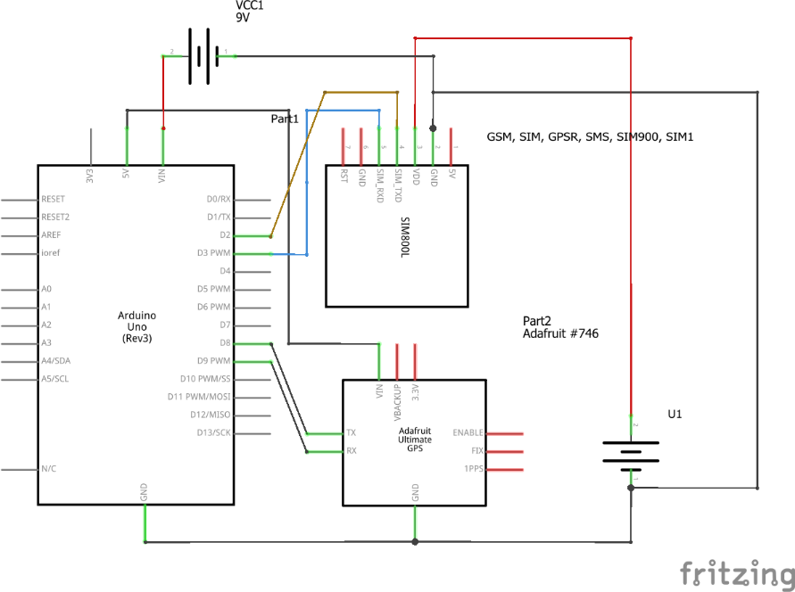

Figure 4 Schematic of first prototype of core module (Wykerd, 2018)

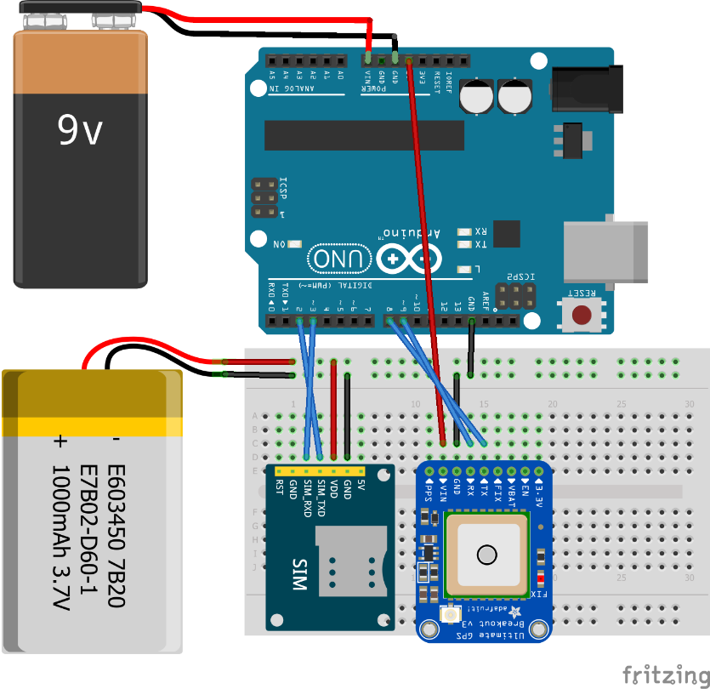

Figure 5 Breadboard layout of first prototype of core module (Wykerd, 2018)

The GSM module will interface with the MCU(Arduino) by wiring the TX (Transmit) and RX (Receive) of the module and digital pin 2, which will act as the MCUs RX (going to TX of module) and 3, which has PWM (Pulse Width Modulation) to transmit commands to the module. The GPS will interface with the module by wiring the module’s RX to digital pin 9 of the MCU and the TX to digital pin 8 of the MCU. The interfacing between the modules is required as this is how all the parts will work together.

## Assembly

The board was assembled on a breadboard using Figure 5 above as reference during the assembly. The hardware was tested beforehand in step 2 on page 7 to decrease the chance that the prototype would fail. The final prototype is shown below in Figure 6.

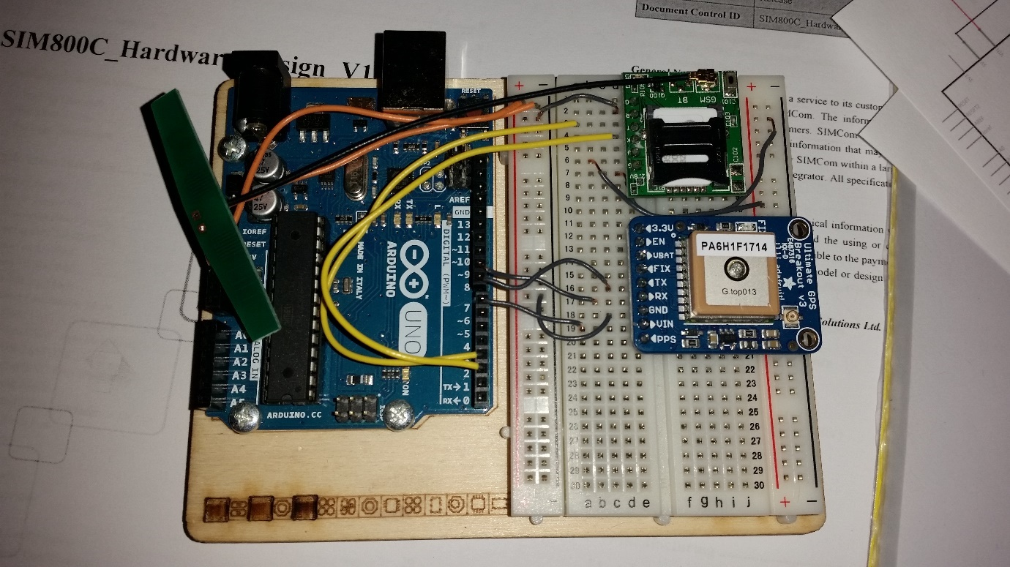

Figure 6 Image of breadboard assembly (Wykerd, 2018)

The wiring of the circuit was done by hand by Daniel Wykerd as was all the other assembly procedures. There was decided on using the power that the Arduino obtained via USB connection to the computer as the power source for the Arduino and GPS Module rather than a 9V-battery.

Another feature was added to the design to allow the user to turn off the GPS module. This is accomplished by connecting the GPS module’s VCC to pin 7 of the Arduino instead of directly to the Arduino’s 5V output.

## Software

After the hardware was designed, software had to be created for the MCU so that the device will function. This software was made using the Arduino language which is a set of C/C++ functions.

Firstly, a program that can read and respond to specific SMS commands was created and tested. To communicate with the GSM, Arduino’s GSM Library (that was preinstalled on their IDE) was used and their website utilized to gain knowledge of the functions included in the library (Arduino, n.d.). At this point, the GPS was not yet implemented into the code (this code can be found in the project journal on the 6th of February 2018).

Next, it was time to implement the GPS location. To do this Adafruit GPS library was used, but this library clashed with the functions of the GSM library. Thus, an alternative was needed: TinyGPS++, this library was much more lightweight than Adafruit’s and AltSoftSerial was also used as an alternative to the IDE’s built-in SoftwareSerial library as it also clashed with the GSM library. A revision of the code was created with these libraries and can be found in the journal on the 7th of February 2018 and later the code was further adapted to the more final code available in the journal on the 10th of February 2018.

Lastly, GPS off feature was added (the code of which is available in the journal on the 10th of March). This code was the final code for this prototype. The code can be found in Appendix B.

The software also lets the Arduino output valuable debugging information through the serial port (Rx and Tx) to the computer via USB and can be viewed using a serial monitor application (like the one built into the Arduino’s IDE). The debugging output works like follows and an example can be found in figure 7 below.

Upon applying power to the module the line “Boot” is printed to the serial port to verify that the device is indeed booting up. Once the device has registered to a network the line “OK” is printed, this means the device is ready for commands. NOTE: this does not mean the device has a GPS fix. If a message is sent to the device the following lines are printed to serial: The sender’s number; the command sent, if the message does not start with a ‘#’ the word “INVALID” will be printed to serial; The word “DEL” meaning that the device has completed the command, deleted the message from the sim card and is ready to receive the next command.

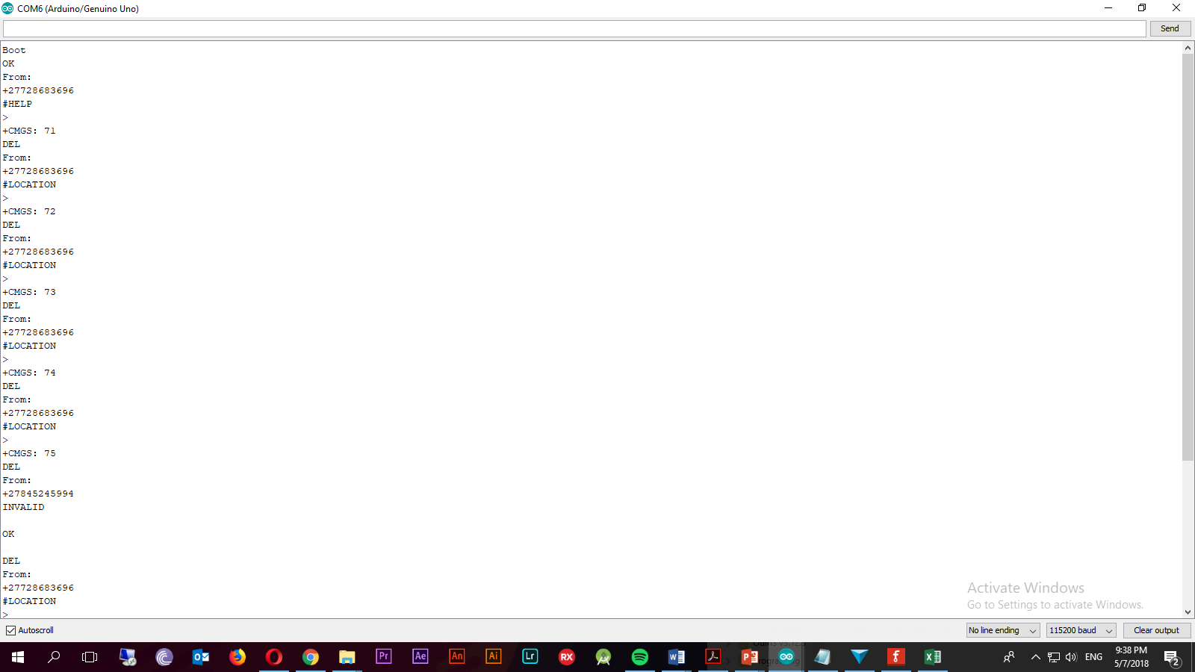

Figure 7 Example of the serial output (Wykerd, 2018)

## Usage of The Device

In this section, an explanation is given on how the user will retrieve the location of the device.

The user will send a command to the device via SMS, there are three possible commands the user can send to the device. The command “#Location” (not case sensitive) can be sent to the number of the sim card inside the device (the device will require a sim card loaded with airtime to send the response back) to retrieve the device’s location. The format of the SMS can be seen in Figure 8 below. The first line of the SMS includes the coordinates, the second includes a link to Google Maps that shows the location of the device on Google Maps. The last line shows the number of satellites that the GPS module has acquired, this is for debugging and to show the quality of the GPS fix. If there is no GPS fix an SMS saying “Acquiring satellites” will be sent.

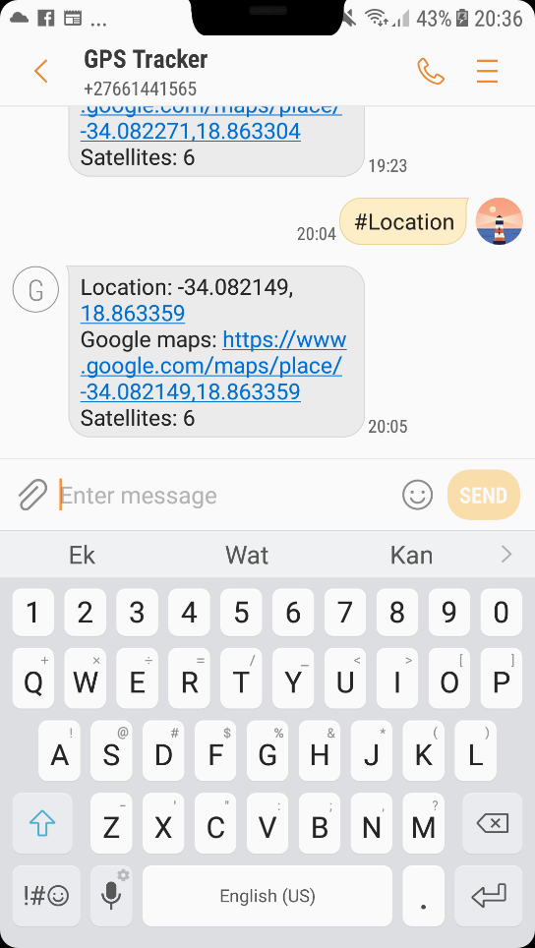

Figure 8 Example of #Location SMS (Wykerd, 2018)

The command “#Help” can be sent to see a list of the possible commands that the device can react to. Lastly, the command “#Off” can be sent to turn off the GPS module to save battery life. The GPS module will automatically turn back on if the user requests the location by sending “#location” again.

## System Diagram

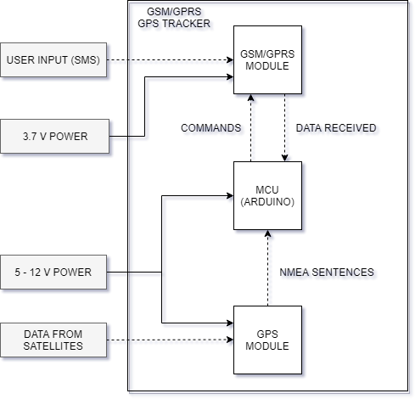

Figure 9 System Diagram of first prototype (Wykerd, 2018).

## Analysis of prototype:

The prototype was analyzed using the design requirements and criteria outlined in the research plan to determine how well the project succeeds in the engineering goal on page 3.

### Requirements

Since the goal of the first prototype was to test the concept of creating a GPS Tracker and not to be reproduced, some of the requirements were not met.

The device is easily manufacturable, but only in small scale, it would be uneconomical to produce this prototype on a mass scale and the electronics of the device is not permanently attached and can easily be disassembled. This easy disassembly was necessary so that debugging can be done fast, and components can be rewired and/or replaced in a matter of seconds.

The device does not get its power from one power source, this issue is addressed in the next prototype by removing the Arduino entirely and opting for a standalone Atmel MCU.

### Criteria

Table 2 Analysis of first prototype to design criteria:

|  |  |  |
| --- | --- | --- |
| Criterion | How well does the device meet the criterion? | Suggested improvements that can be made: |
| The device should draw a low current to prolong the battery life. | The device is powered via the USB of the computer. It does not use a battery as its primary energy source. There are measures in place to preserve power, this includes the “#Off” command that will turns of the GPS module. | This issue can be eliminated by getting rid of the Arduino and using a standalone MCU instead. |
| The device should have a small form factor | The device has a footprint of approx. 12cm*9.5cm*4cm. It meets the criterion very badly. | The device’s size can be cut in half by replacing the Arduino with a standalone MCU. |
| The device should be user-friendly. | The device’s location can be accessed via SMS. The full list of commands can be found under ‘usage of the device’ on page 10. This is a very user-friendly way of retrieving the coordinates.  The hardware, however, is not at all user-friendly. The goal of this prototype was not to make a product for the end user, but rather to test the components and software | At this moment no improvements can be made to make the device more user-friendly on the software side. The device can be physically made more user-friendly by making the device smaller and self-contained (no computer required). |
| The environmental impact should be kept low | All the components used in this prototype is RoHS compliant and is thus free of certain hazardous substances such as lead. | Fewer components can be used to decrease steps in production that create hazardous by-products (like soldering) |
| Cost should be as low as possible | The prototype cost R947.89 to make. | The cost can be minimized by creating a custom PCB with only the required components (no Arduino or breakout boards only the components that are essential for the device to function) on it. |
| Repair and upgradability | The device can easily be repaired and upgraded as it is built on a breadboard. | No improvements can be thought of at this moment |

# **Second Prototype of Core Module:**

## Introduction

The goal of the second prototype is to get rid of the Arduino and replace it with a standalone MCU, the ATMega328p-pu (the same MCU used in the Arduino UNO). The reason for removing the Arduino is to save space and reduce the number of off the shelf components (that cost expensive) so that it can be easily manufactured. The MCU aspect of this prototype will be used in making the final prototype.

This prototype will not make any changes to the software and thus there is no software part of this prototype, to see how the software works refer to page 10. The usage will also remain the same and can be found on page 11.

## Materials / Components Chosen

This prototype repurposes the components used in the previous prototype. The same GSM and GPS module is used. The Arduino UNO’s microcontroller was removed and reprogramed using a second Arduino UNO as an ISP (in-system programmer).

## Cost

This prototype would have cost R

|  |  |  |
| --- | --- | --- |
| Component | Supplier | Cost per unit |
| Atmega328p-pu | Mouser | R 32.34 |
| SIM800L Breakout | Communica | R 236.84 |
| FGPMMOPA6H Breakout | Communica | R 635.95 |
|  | Total: | R 905.13 |

## Replacing the Arduino with a Standalone MCU

Getting rid of the Arduino was quite straightforward. Arduino has a great tutorial on their website on how to use an Arduino as an ISP to burn a bootloader onto a new MCU. Although the MCU used in this prototype already had the Arduino bootloader burned to the flash, it required an external 16MHz oscillator (the ATMega328p) which has an 8MHz internal oscillator that can be used instead of an external oscillator by changing some of the MCU’s fuse bits. This way 3 more components could be removed from the board (the crystal and 2 18pF ceramic capacitors). The board profile that was used to change the bootloader can be found on Arduino’s website (find the link in the references). See the figure below on how the Arduino was used as ISP to burn a new bootloader to the MCU.

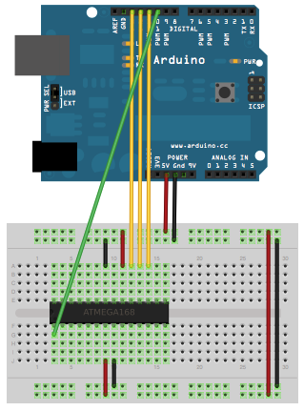

Figure 10 Arduino as ISP (Arduino, n.d.)

After the bootloader was burned onto the MCU, programs could easily be uploaded to the MCU using an USB-to-TTL FTDI chip that is connected to the serial port of the MCU. To save cost the Arduino board’s FTDI chip was used to program the ATMega instead of purchasing a new USB-to-TTL board.

The serial connections (RX and TX of the modules) between the MCU and the GSM and GPS modules also had to be rewired as the Arduino has been removed. The bootloader on the MCU works in the exact same way as the bootloader on the Arduino’s MCU and rewiring is a simple case of figuring out where which input/output pin connects to the MCU’s pins. This could have been done manually by using the continuity tester on a multi-meter and checking to which output the MCU’s pins connected or alternatively by using the following diagram seen below of the ATMega168 and ATMega328p’s Arduino pinout that has been pre-tested. This was the route followed in this project.

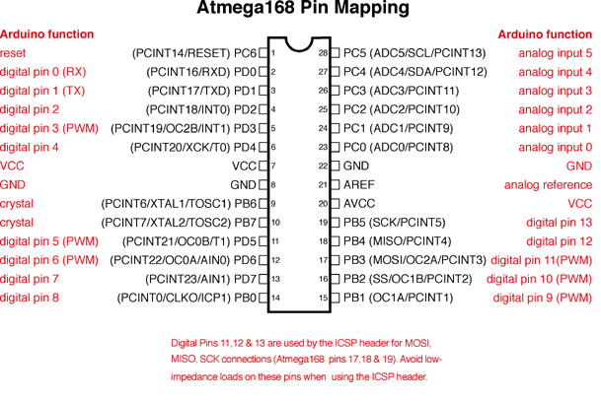

Figure 11 Atmega328p and 168 Arduino Pin Mapping (Arduino, n.d.)

## Schematic and Breadboard Layout

The following two figures show the design of the second prototype and was created using Fritzing, a free open-source software that allows you to digitally make your own schematic and breadboard layout.

During the design phase, a feature was omitted (the GPS off feature) and was only noticed after the completion of the final prototype and can thus not be changed. This can be reimplemented in a later prototype.

The design does not include the VCC and GND input, but this input can be seen in the figures in the assembly section of the second prototype.

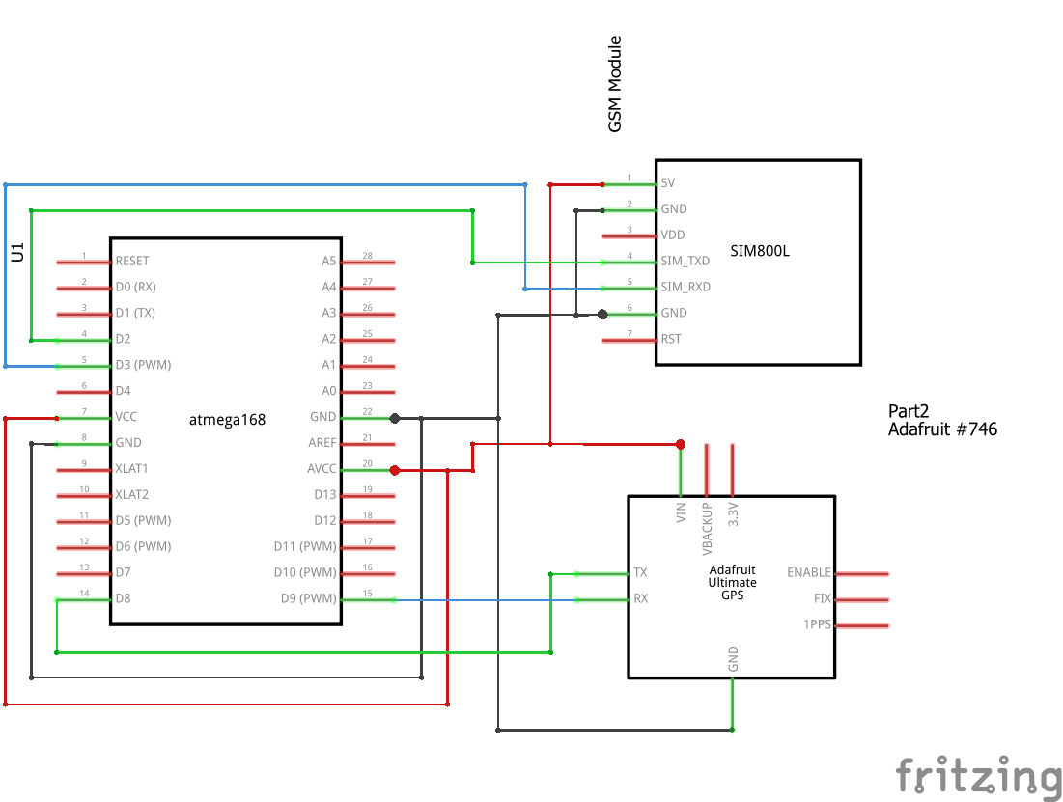

Figure 12 Schematic of second prototype of core module (Wykerd, 2018)

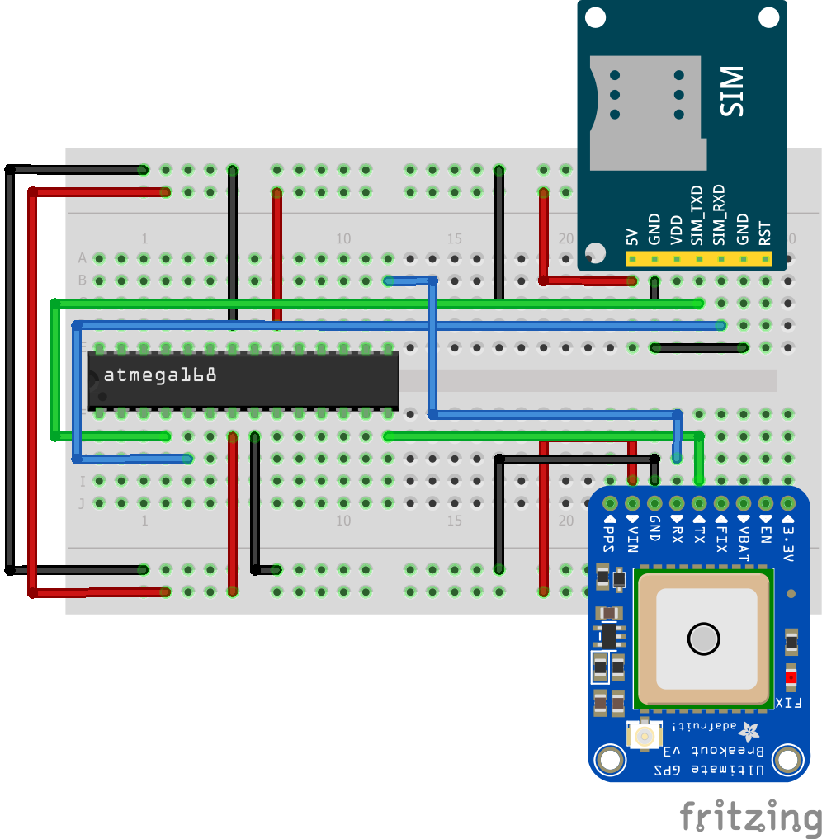

Figure 13 Breadboard layout of second prototype of core module (Wykerd, 2018)

## Assembly

Assembly was like the first prototype’s assembly procedure. All the assembly procedures were done by Daniel Wykerd, including burning of the bootloader to the MCU, programming of the MCU and wiring of the components on the breadboard. The figures below show the results.

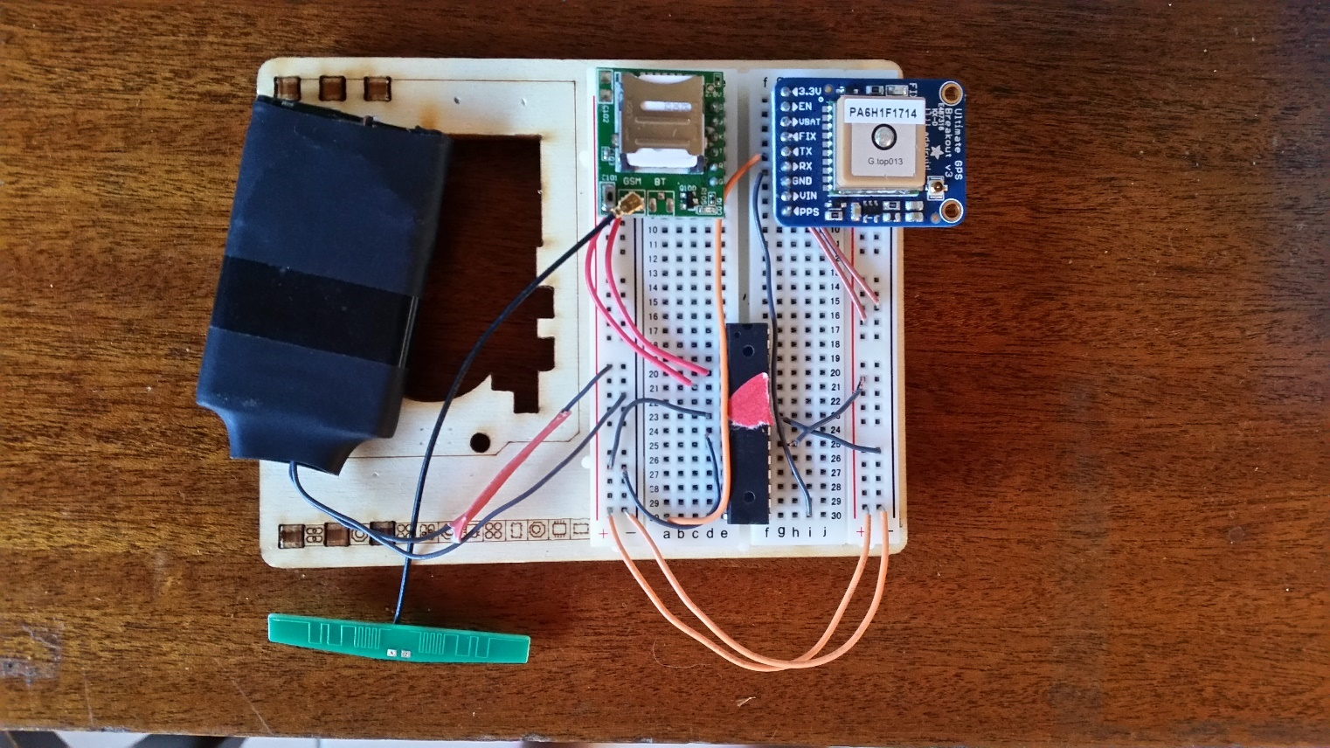

Figure 14 Final assembly of second prototype of core module (Wykerd, 2018)

Power is supplied in parallel to all components. The power source is a 3.7 V Lithium Ion Polymer (Li-Po) battery salvaged from an old cell phone.

## System diagram

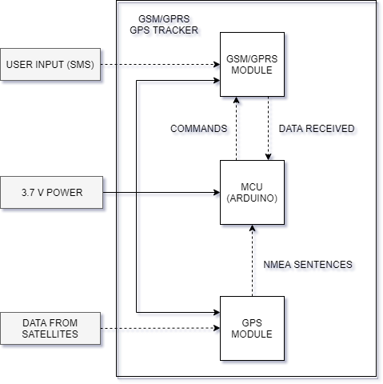

Figure 15 System diagram of second prototype of core module (Wykerd, 2018)

## Analysis of prototype

The prototype was analyzed using the design requirements and criteria outlined in the research plan to determine how well the project succeeds in the engineering goal on page 3.

### Requirements

This prototype met more of the requirements than the first but still has plenty of shortcomings since it is still on a built breadboard and was not meant to be used by an end-user. The device is still not easily mass producible and is still not user-friendly in terms of hardware. The device however now runs from a single battery unlike the first prototype and has fewer parts lowering the cost.

### Criteria

Table 3 Analysis of second prototype to design criteria

|  |  |  |
| --- | --- | --- |
| Criterion | How well does the device meet the criterion? | Suggested improvements that can be made: |
| The device should draw a low current to prolong the battery life. | The device draws a low current. The average amp draw is around 50 - 60 mA max. | There are not many improvements that can be made except that the ‘#off’ command can be reimplemented. |
| The device should have a small form factor | The device has a footprint of approx. 5.5cm*8.5cm*2cm. It meets the criterion poorly but better than the first prototype. | The device’s size can be diminished several times by creating a custom PCB with only the bare minimum components |
| The device should be user-friendly. | The device’s location can be accessed via SMS. The full list of commands can be found under ‘usage of the device’ on page 10. This is a very user-friendly way of retrieving the coordinates.  The hardware, however, is not at all user-friendly, but the goal of this prototype was not to make a product for the end user but to remove the Arduino in preparation for designing the final PCB | At this moment no improvements can be made to make the device more user-friendly on the software side. The device can be physically made more user-friendly by creating a custom PCB with only the bare minimum components |
| The environmental impact should be kept low | All the components used in this prototype is RoHS compliant and is thus free of certain hazardous substances such as lead. | Fewer components can be used to decrease steps in production that create hazardous by-products (like soldering) |
| Cost should be as low as possible | The prototype cost R905.13 to make. | The cost can be minimized by creating a custom PCB with only the required components (no Arduino or breakout boards only the components that are essential for the device to function) on it. |
| Repair and upgradability | The device can easily be repaired and upgraded as it is built on a breadboard. | No improvements can be thought of at this moment |

# **Third Prototype of Core Module:**

## Introduction

This prototype will use all the designs made and results obtained in the previous two prototypes to create a fully functional, self-contained Modular GSM/GPRS GPS Tracker.

The device will be contained on a single multi-layered PCB designed from scratch using the chips’ datasheets as a reference during the components choosing and design stage. The reason for creating a custom PCB is so that the device can be easily manufactured as PCB fabrication is a very fast process.

There will be no off the shelf components used in the build resulting in a steep drop in the price per unit (especially if the device is made in large quantities where the components are brought in bulk). All the components used will be SMT (Surface Mount Technology) components, because these components are much smaller than their through-hole counterparts and these types of components are the most common type components used in factories. All the items can be purchased straight from the component manufactures and assembled by pick and place machines (a piece of equipment used in factories to automatically apply solder paste and thereafter the SMT components on the unpopulated boards) in factories, minimizing the need for human involvement in production (which will further decrease production cost). It will be possible for the entire device to be assembled in one factory (except for the bare components which will be sourced from suppliers).

A case will also be designed to house the device. The case will offer means of mounting the device to other modules.

## Choosing the Main Components:

There was decided on using similar components as the components used in the previous two prototypes as these components were already tested to work with the software and hardware configuration.

The MCU chosen is the Atmega328P-AU, the same IC as the Atmega328P-PU but in a different package, TQFP (Quad flat package) instead of DIP package (Dual in-line package). The reason for choosing this component is because it has enough flash memory for the software (as the software is quite large due to the use of libraries) and is the same chip as the one used in the previous two prototypes.

The GSM/GPRS Module chosen is the SIM800C module, this chip is like the SIM800L module used in the previous prototypes but has an easier to solder package, it has its contacts around the chip instead of under the chip in a land grid array (LGA) package. This makes it easier to solder the component. Another advantage of the SIM800C is its size is 17.6*15.7*2.3mm according to its datasheet (SIMCom Wireless Solutions, 2017) in comparison to 15.8*17.8*2.4 mm (SIMCom, 2015). It does not have any unnecessary features like Bluetooth like the SIM800H has. It is thus a better module to use in this case.

The FGPMMOPA6H has been chosen as it has already been used in the other two projects. It served its purpose nicely and is thus used again in this prototype.

## Breakdown of Schematic

The schematic for this prototype was created in EasyEDA a free online CAD software for schematic and PCB layout creation.

The schematic is broken into three parts: The GPS Module, MCU and GSM Module.

The full schematic can be found in Appendix C.

All resistors, MLCCs (Multi-Layer Ceramic Capacitors) and Tantalum capacitors are 1206 packages.

### The GSM Module

The GSM module was designed first using the SIMCOM800C Datasheet listed in the references and added in the journal. Below is an image of this section.

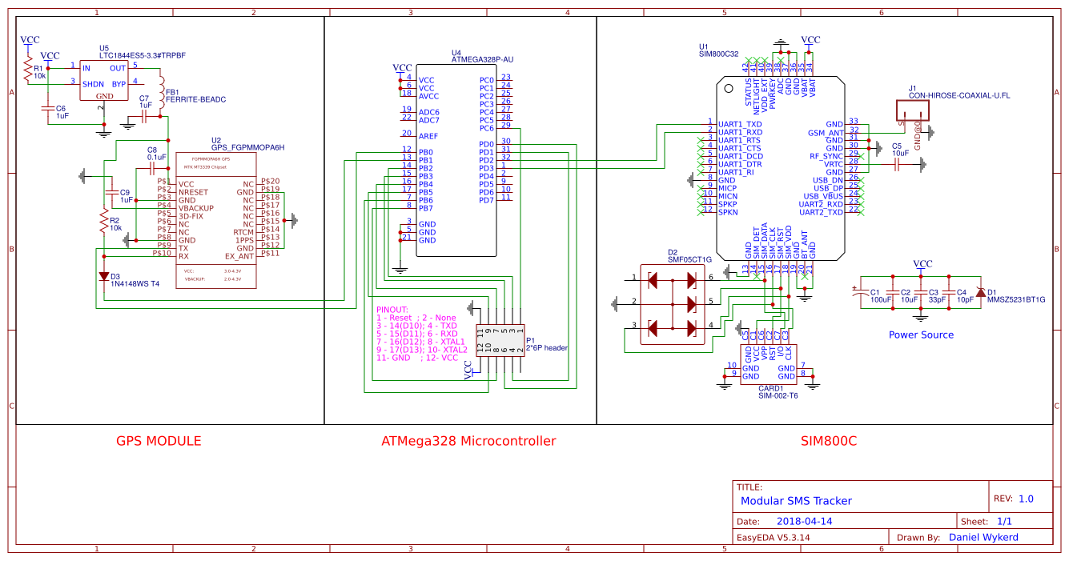

Figure 16 GSM Section of Schematic (Wykerd, 2018)

The power source was designed using page 17 of the datasheet as reference.

SIM-002-T6 was chosen as the sim card reader (CARD1) as it has a push to insert and push to eject mechanism. This mechanism works the best with the case that was designed to house the PCB as the SIM can easily be ejected.

The purpose of the diode bridge SMF05CT1G (D2) is to prevent electrostatic discharge (ESD) whilst the SIM is inserted. It can be omitted but is there to protect the GSM module.

The GSM antenna will connect to the GSM module via the coaxial jack (J1).

### The GPS Module

The GPS module’s datasheet can be found in this project journal and in the references. Here is a breakdown of the components used:



Figure 17 GPS Section of Schematic (Wykerd, 2018)

U5: The GPS module has a typical voltage input of 3.3 V. The datasheet recommends a voltage regulator to keep the voltage supplied to the module constant. Microchip’s MIC2552-3.3 Low Dropout Regulator (LDO) was chosen to provide power to the module – the schematic shows another LDO, but this is because the MIC2552 was not in EasyEDA’s library of components.

R1: Pull up resistor that keeps the SHDN/ENABLE pin on a high logic level to keep the LDO powered on.

FB1: The ferrite bead is used to minimize EMI (Electromagnetic Interference). This is called an RF Choke. It does not let high frequencies through. It has an impendence of 600Ohm at 100MHz according to its datasheet (Murata, n.d.). This is the same as the specs of the ferrite bead recommended by the GPS module’s datasheet.

R2 and D2 restrict the Rx input to 3.3V according to Adafruit’s reference (Adafruit Industries, 2012).

### The MCU

The MCU is the same as the one used in the previous prototypes. Wiring is thus similar. Below is the schematic:



Figure 18 MCU Section of schematic (Wykerd, 2018)

P1: Male header used for burning bootloader to MCU and programming the MCU. Also used for debugging via serial. The header can also be used by other modules to add functionality to the device as there is 4 extra digital I/O pins available for use by an external device (software update required for modules to take advantage of the MCU’s extra pins).

## Bill of Components (BOM)

Table 4 BOM of third prototype



The total cost of the project can be viewed in Appendix A.

## PCB Layout

The PCB layout was designed in EasyEDA a free web-based CAD software for creating schematics and PCBs.

The first attempt at designing a PCB was unsuccessful as traces were not matching the right places. This failed attempt is in the journal.

Below is a figure of top PCB layer: 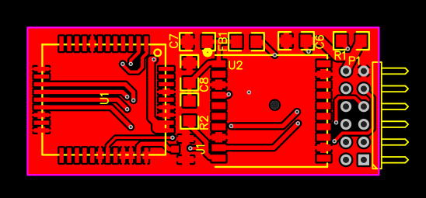

Figure 19 Top Layer of PCB (Wykerd, 2018)

The GSM module, jack and GPS module will be mounted on the top layer.

Below is a figure of the bottom layer:

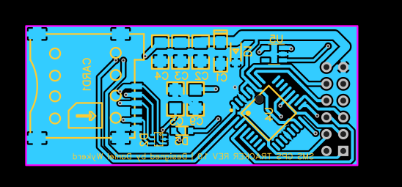

Figure 20 Bottom Layer PCB Layout (Wykerd, 2018)

The MCU, Card reader, and most VCC lines will be mounted to the bottom layer.

Below is a figure of the board with all layers:

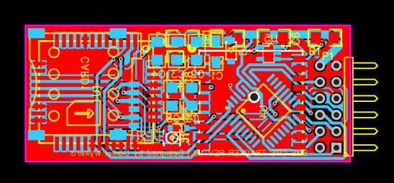

Figure 21 PCB Layout (Wykerd, 2018)

## System Diagram

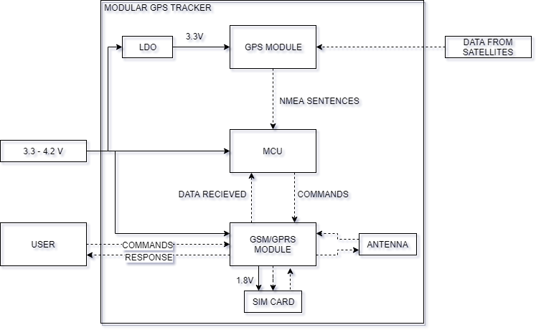

Figure 22 System Diagram of final prototype (Wykerd, 2018)

## Case design

### Design 1:

A case was designed for the PCB to fit in. The case was designed in 123D Design, a free CAD software.

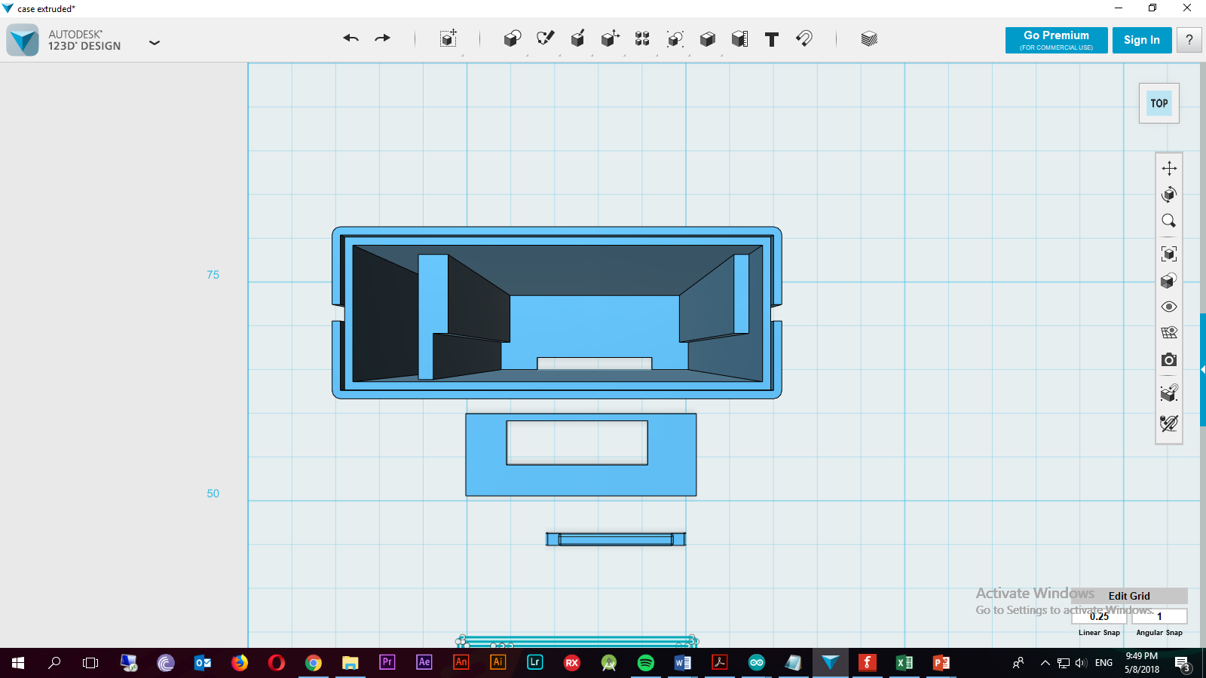

Figure 23 Top view of case (Wykerd, 2018)

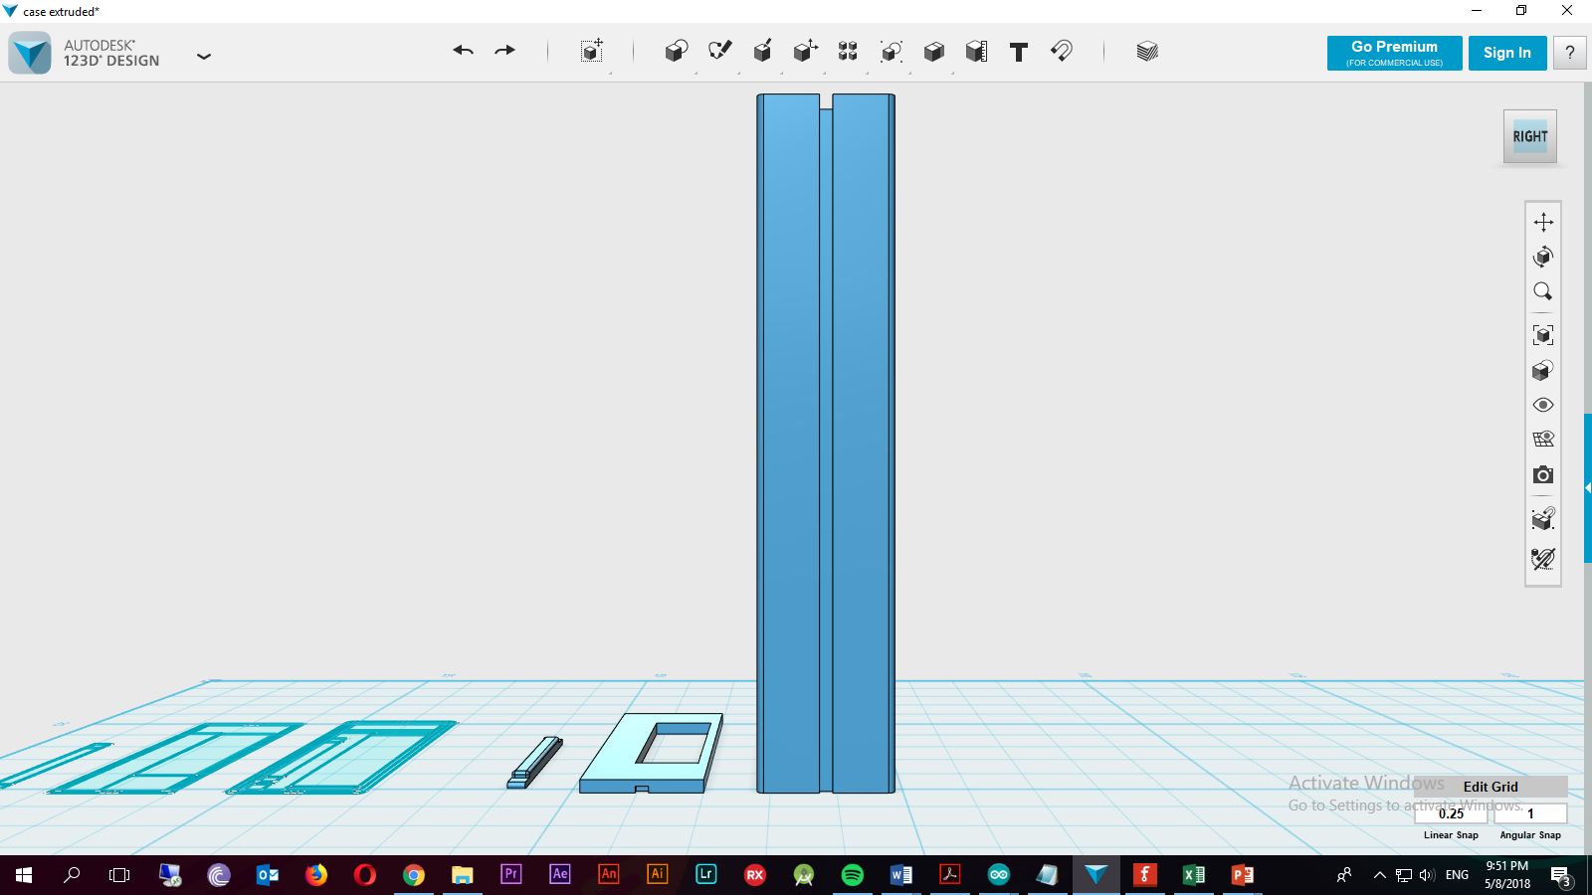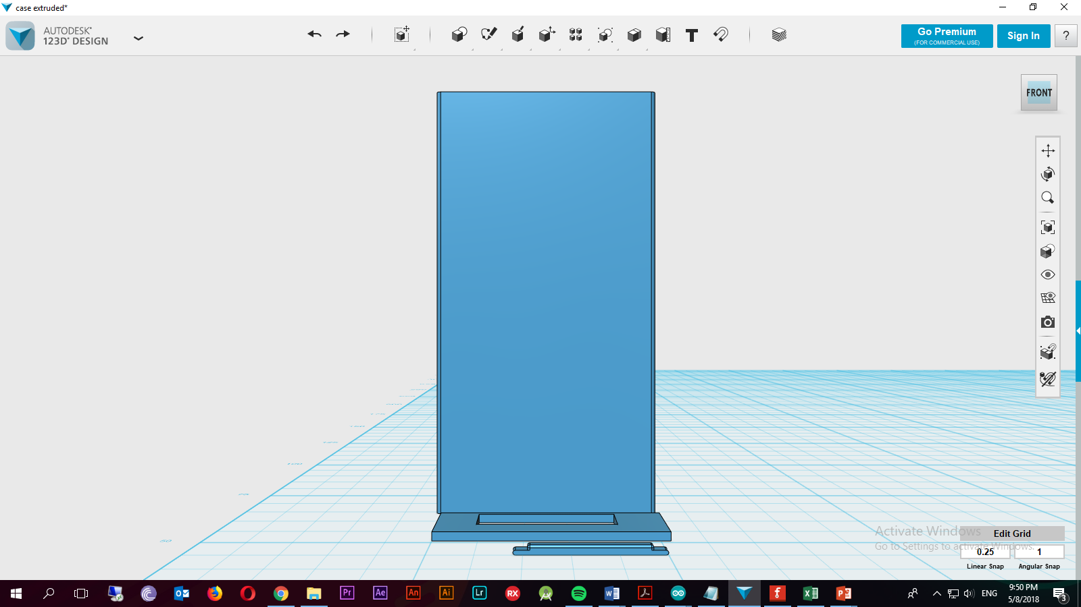

Figure 24 Right view of case (Wykerd, 2018)

Figure 25 Front view of case

The case has grooves on the sides for other modules to slide onto. The Second rectangle with the hole in goes on top of the case after the PCB and antenna is inserted into the case. The small rectangle in the lower end of the top view is a cap for the SIM slot. It is pushed into the sim hole after the sim card is installed in the slot to prevent dust and other materials from damaging the PCB. The case is not water resistant!

Here are the dimensions of the top view

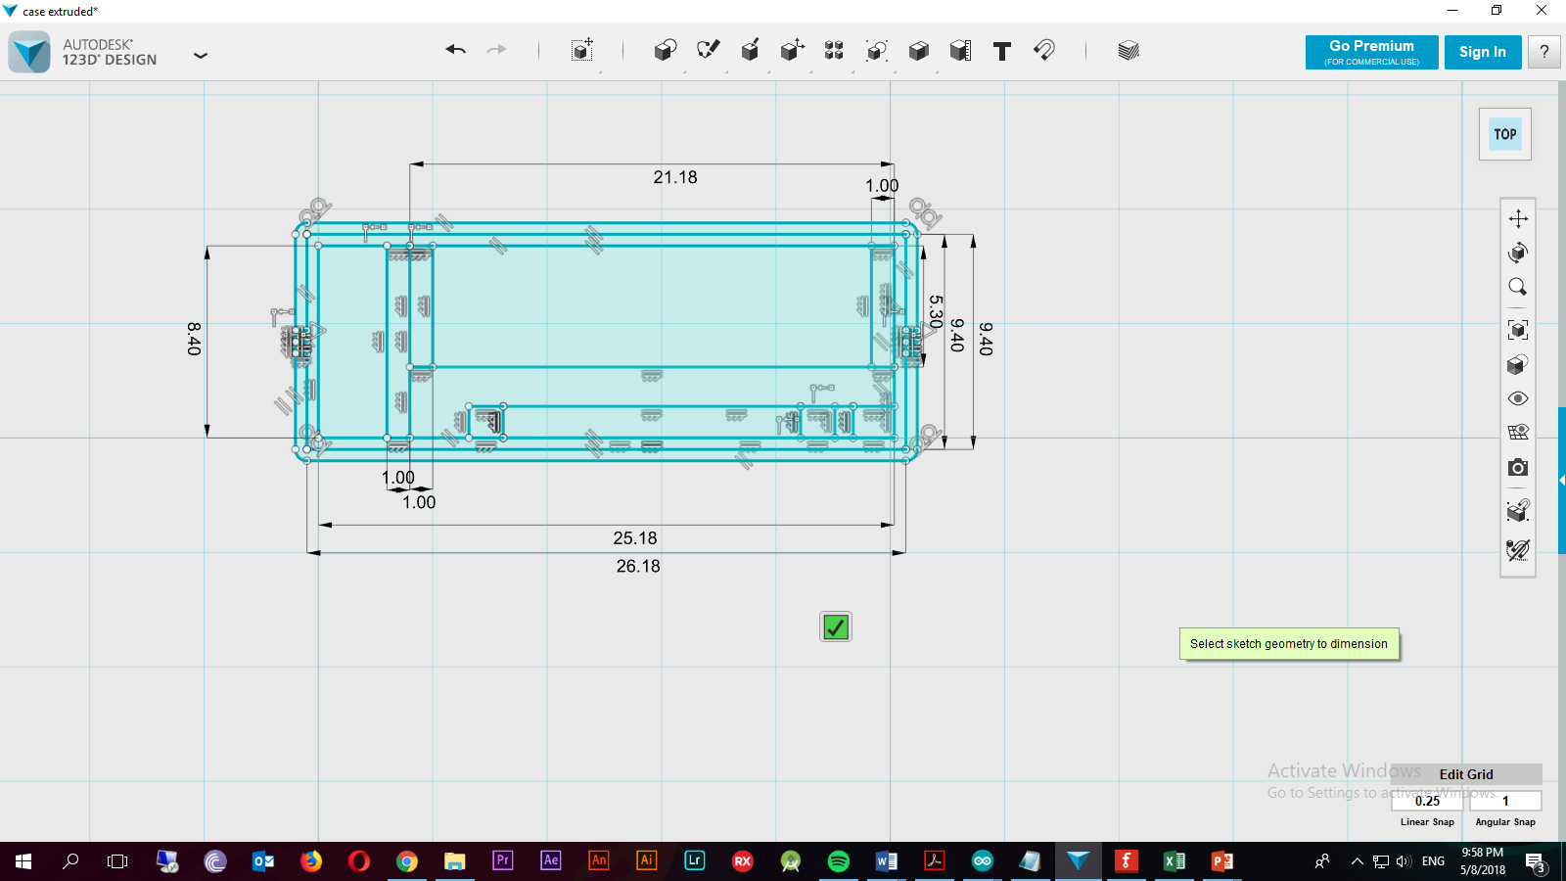

Figure 26 Dimensions of Top view of case (Wykerd, 2018)

The case is approx. (the headers add height) 22 mm high after the PCB is inserted. This case was printed by Grant Parkes but it was discovered that the tolerances added to the dimensions were to small and the PCB did not fit.

### Design 2

A new case was designed with better dimensions. It is very similar to the first design. It also has grooves for other modules to attach to and is also not waterproof.

This case was designed in Solid Edge an AutoCAD software by SIEMENS under an education license.

See Appendix E for the drawing of the case

The case was once again printed by Grant Parkes.

The case helps make the device more modular and protects the device’s circuitry. The case can be made waterproof in later revisions. Due to the simple design of the case, it is very simple for third party developers to create their own additional modules to be used with the device.

## Assembly

Assembly required special equipment and knowledge of SMT soldering. Thus, Johann Erasmus was asked to assist with soldering during the first attempt of assembling the prototype. He soldered the board under a microscope using the schematic as a reference. The GPS module was left out to test the MCU and GSM module first. It turned out that the MCU got bricked or fried while attempting to burn the bootloader to the fuses of the MCU. Johann Erasmus and Danie Ludick (PhD) assisted with debugging but no solution was found. Below is a figure of the bricked board:

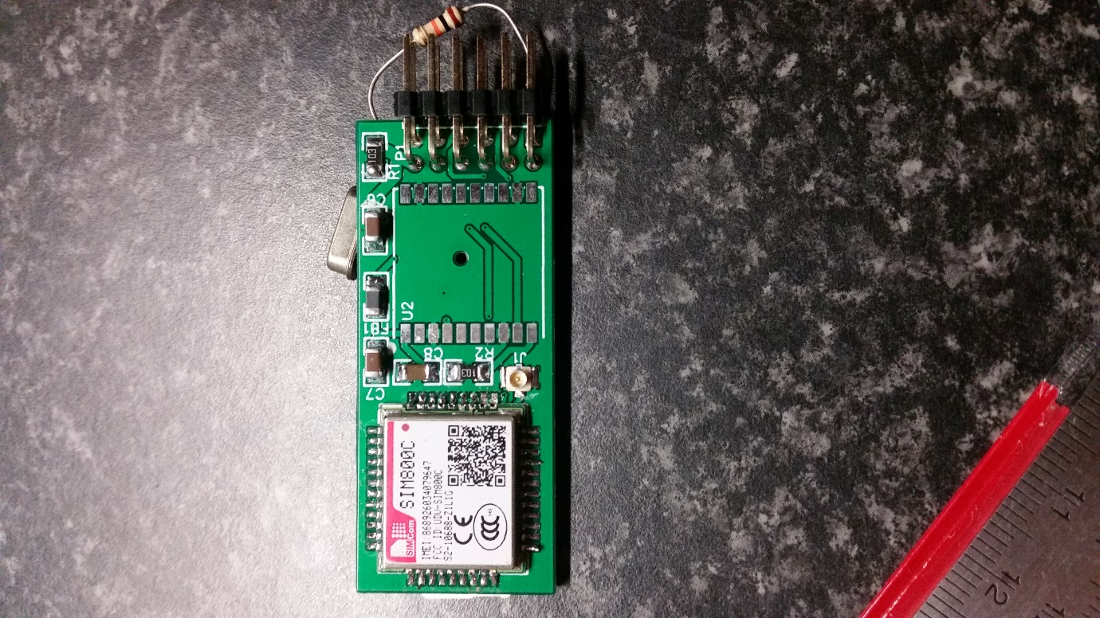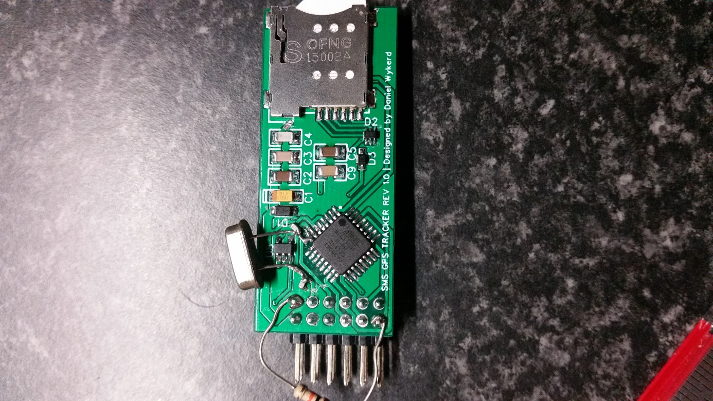

Figure 27 Faulty board

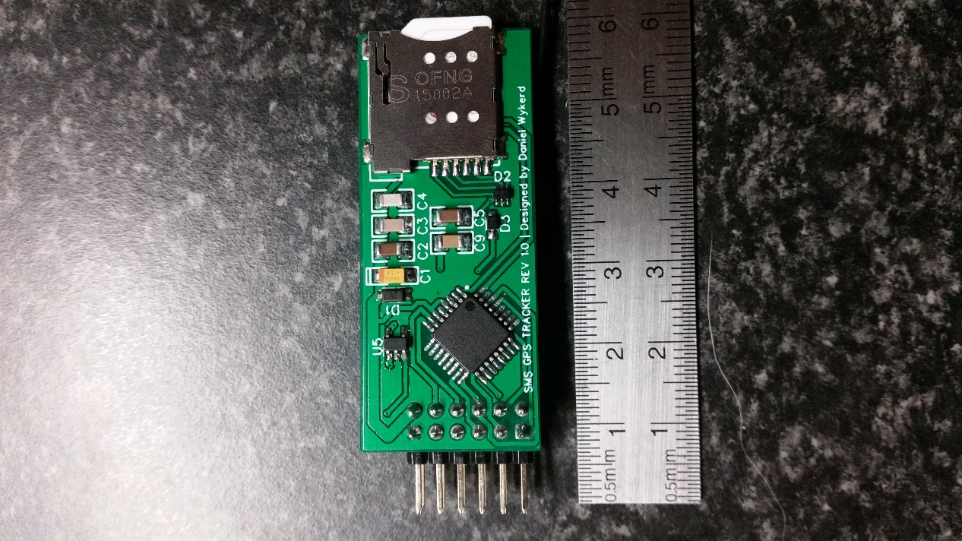After consulting with Dr. Ludick it was decided to take the PCB and parts to the University of Stellenbosch for them to populate/solder a new board. This time a 10K Ohm pull up resistor was added between VCC and reset to prevent the board from resetting. After this component was added, the bootloader did burn to the MCU. Here is a picture of the final board:

Figure 28 Bottom of Assembled PCB

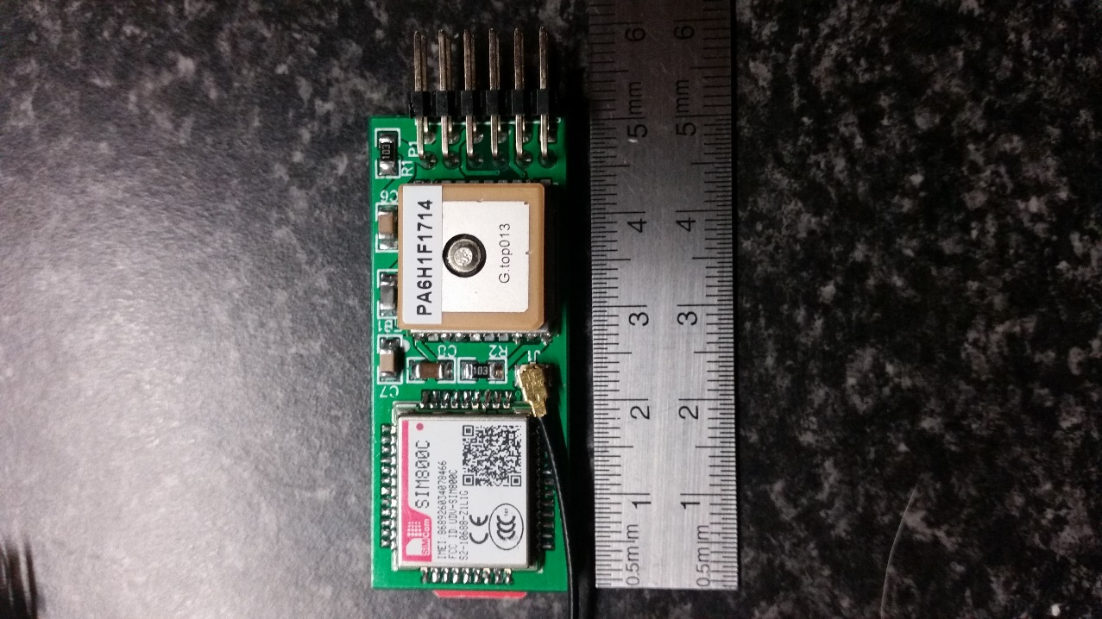

Figure 29 Top of Assembled PCB

A makeshift programming station was built by Daniel Wykerd to program and debug the board via serial. Below is an image of the programmer:

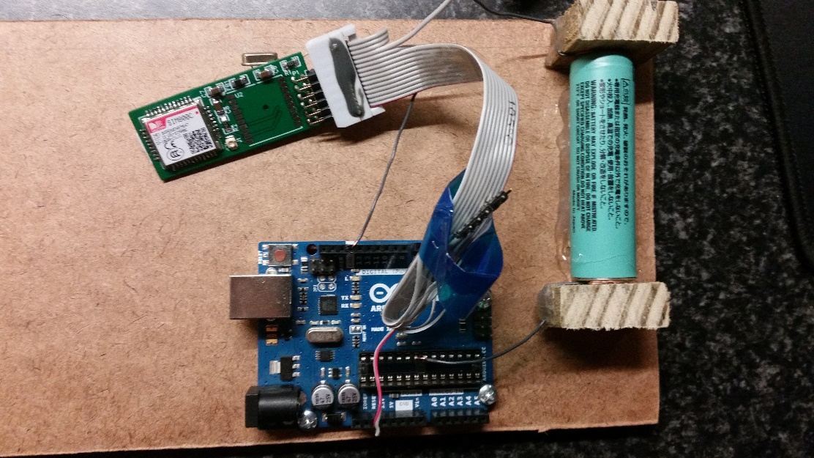

Figure 30 Programming Station

## Software

The software is the same as the software of the first two prototypes except for losing the ‘#Off’ command. The final software is available in Appendix D.

## Analysis of results

The prototype was analyzed using the design requirements and criteria outlined in the research plan to determine how well the project succeeds in the engineering goal on page 3.

### Requirements

The device meets all the requirements set out in the research plan.

The device is easily manufacturable because the device is contained on a single multi-layered PCB thus the device can be easily manufactured as PCB fabrication is a very fast process.

There is no off the shelf components used in the build resulting in a steep drop in the price per unit (especially if the device is made in large quantities where the components are brought in bulk). All the components are SMT components. These types of components are the most common type components used in factories, it can easily be assembled by pick and place machines minimizing the need for human involvement in production (which further decreases production cost). It is possible for the entire device to be assembled in one factory (except for the bare components which need to be sourced from suppliers).

The device uses pre-existing communication infrastructure, it uses SMS to communicate with the user. Thus, it does not require a subscription to a third party. Airtime can be loaded onto the SIM card and the device will work.

The device is modular. The code can be changed using the serial interface of the MCU and there are 3 digital I/O pins available for use by other modules added later. The case can easily be slid into other modules using the grooves on the sides.

The device has a battery life of over 48 hours on a 2350 mAh according to tests done. These tests are however slightly inaccurate as the batteries were old and used. The raw data of the test can be found in the journal of the project.

The cost per unit is far below R1000 (R293.47 to be precise)**.**

### Criteria

Table 5 Analysis of third prototype of core module to design criteria

|  |  |  |
| --- | --- | --- |
| Criterion | How well does the device meet the criterion? | Suggested improvements that can be made: |
| The device should draw a low current to prolong the battery life. | The device draws a low current. The average amp draw is around 50 mA max. It lasts longer than 48 on a charge of a 2350 mAh battery | There are not many improvements that can be made except that the ‘#off’ command can be reimplemented. |
| The device should have a small form factor | The device has a footprint of 50.1 mm * 21.1 mm * 8.4 mm. It meets the criterion extremely well. | The GSM antenna can be put on the same PCB |
| The device should be user-friendly. | The device’s location can be accessed via SMS. The full list of commands can be found under ‘usage of the device’ on page 10. This is a very user-friendly way of retrieving the coordinates.  The hardware is very user-friendly especially if it is in a case. The device is sturdy, and it is very easy to add modules | At this moment no improvements can be made to make the device more user-friendly on the software side. The device can be physically made more user-friendly by creating more modules for the device. |
| The environmental impact should be kept low | The prototype uses lead solder which is a hazardous substance. | The board can be made RoHS compliant by using lead-free solder. |
| Cost should be as low as possible | The module cost only R293.47 to make. This is a huge improvement above the previous prototypes | The cost can be reduced by buying items in bulk |
| Repair and upgradability | The device uses SMT components which is not easily replaceable. The case is made of plastic and can be manufactured for cheap and replaced easily Software, however, can easily be upgraded to make the device work with different modules or fix bugs (if any are found) | It can be made easier to replace broken components |

# **First prototype of Datalogging Module:**

## Introduction and Materials Chosen

The goal of the first prototype is to test the concept of making a datalogger and to pick out the correct supporting components for the SD card. Once again, like for the first prototype of the core module, all large / SMD components were brought in the form of breakout boards for easy assembling, debugging and designing.

Components were also brought locally to preserve time. Components purchased included a SD card and SD card slot breakout board with a level shifter (to convert the 3.7v-4.2v logic of the tracker to the 3.3v logic of the SD card). The datalogger also required an MCU to control writing to the SD card as the MCU on the tracker had an insufficient amount of ram. Thus, another attmega328p would be needed, but for the sake of this prototype an Arduino UNO/NANO was used. See Appendix A for the total cost of the project.

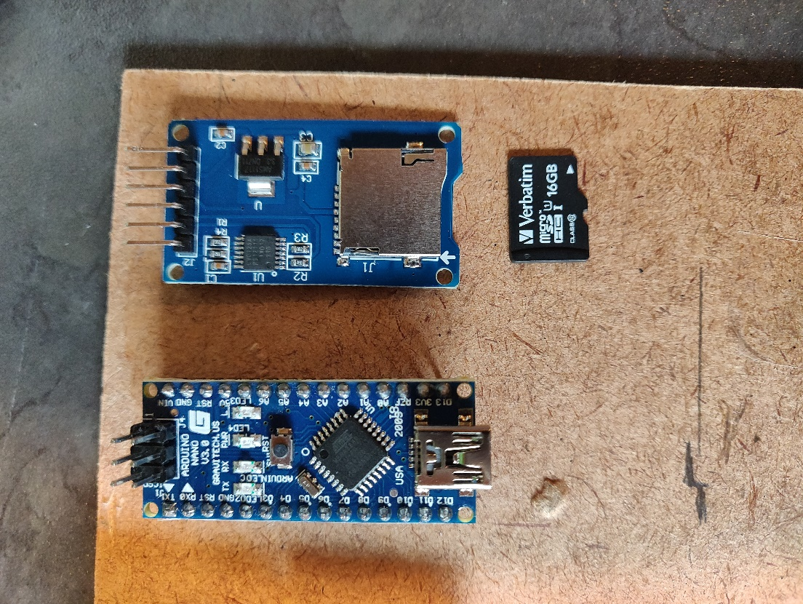

Figure Image of main components (Wykerd, 2018)

## Testing the components

Before designing the prototype, the SD card module was first tested using the SD library provided by the Arduino IDE and the file example. This proved successful.

## Schematic and Breadboard Layout:

The following two figures show the design of the first prototype and was created using Fritzing, a free open-source software that allows you to digitally make your own schematic and breadboard layout.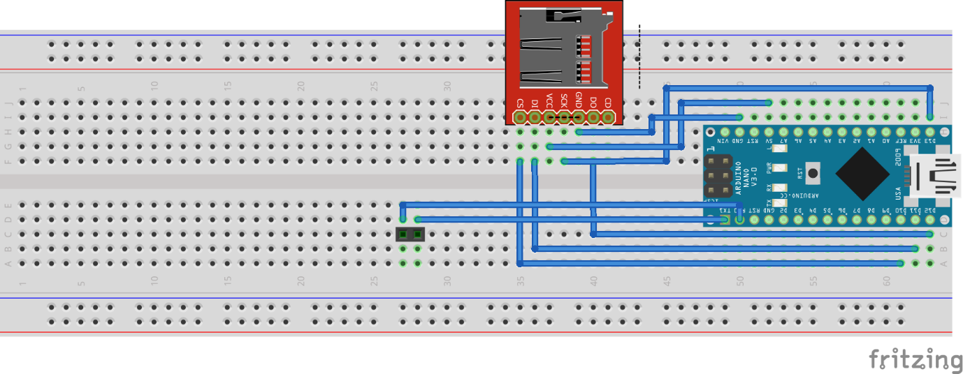

Figure Breadboard layout of first prototype of datalogger (Wykerd, 2018)

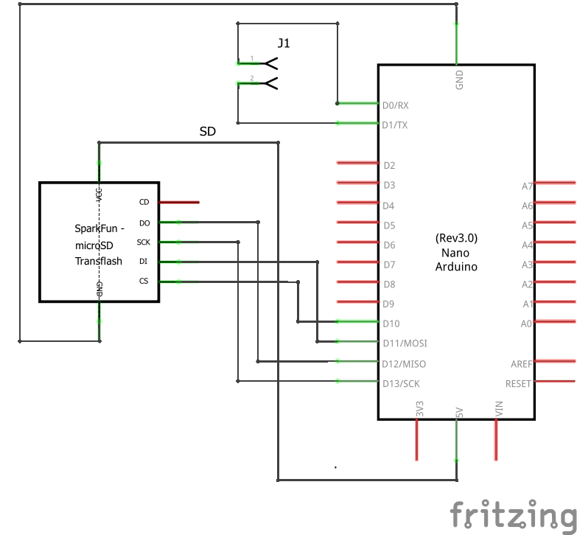

Figure Schematic of first prototype of datalogger (Wykerd, 2018)

The schematic is quite straight forward. It utilizes a second MCU to control writing to the SD card. It communicates/interfaces with the SD Card’s NAND memory using SPI (Serial Peripheral Interface) via pins D11(MOSI), D12(MISO) and D13(SCK). The Li-Ion battery connects to J1 to provide the device with power.

Not indicated on the schematic is the interface between the datalogger MCU and the MCU of the core module. The core module’s MCU pin D11 is connected to the datalogger’s MCU Transmit (Tx) pin and the core module’s MCU pin D12 is connected to the datalogger’s MCU Receive (Rx) pin.

## Assembly

The device was assembled on a breadboard using the breadboard layout (Figure 32) as reference. Below is an image of the result:

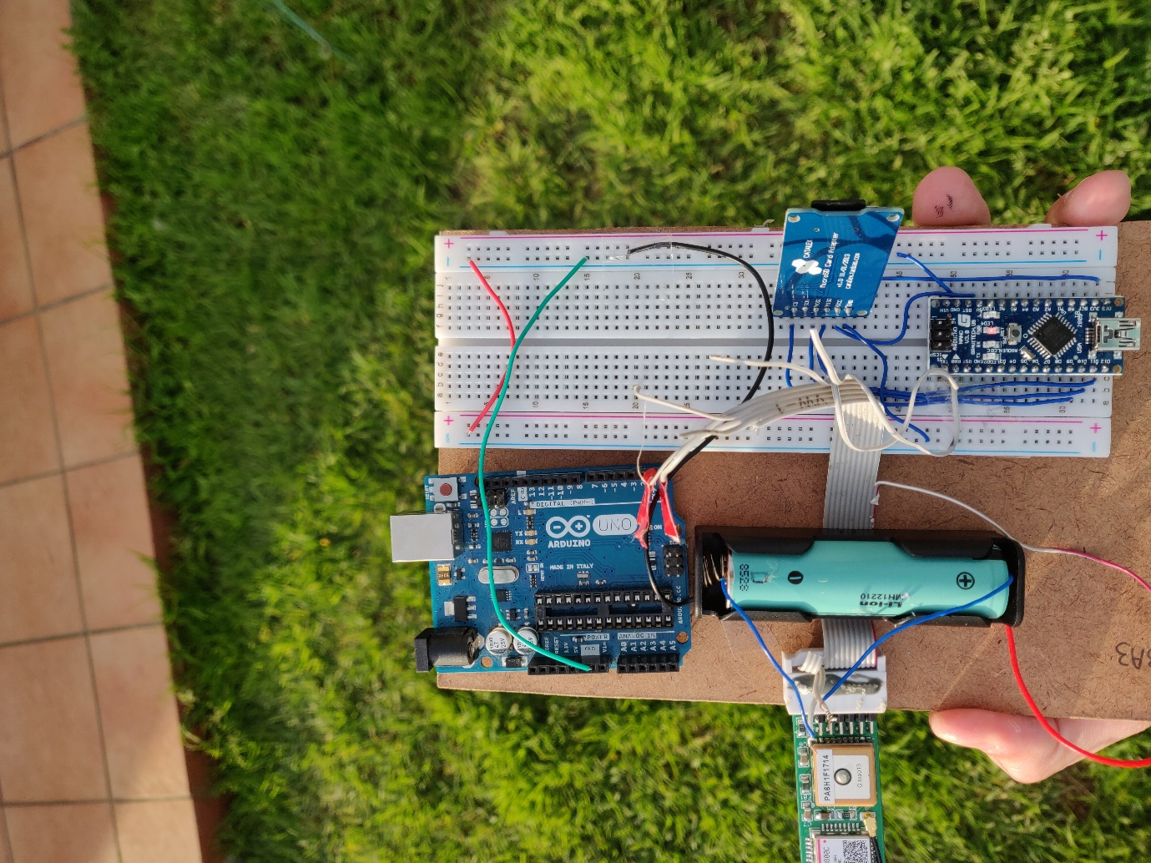

Figure Assembly of the first datalogger prototype (Wykerd, 2018)

All assembly procedures were completed by Daniel Wykerd. The Arduino UNO in the top left of the figure is only used for the USB to TTL chip to communicate with the core module for debugging and programming purposes.

## Software

A new version of software had to be written from the ground up to be used burned to the core module’s MCU to allow for communication with the datalogger. Due to the low amount of ram of the ATMEGA328P it was required to code a more efficient way to communicate with the GSM module as the Arduino IDE’s GSM library uses a high amount of ram.

For first a version of code (Appropriately named Dev Build 2, see appendix F for a description of naming scheme of software versions) Adafruit’s fona library was used to replace the GSM library, but this version of code was never completed as it was clear that a more efficient approach could be followed. This version of the code can be found in the project journal.

Thus, another less ram intensive version of code was created, named Dev Build 3, this version did not use a library to communicate with the gsm module and instead all communication procedures were coded from scratch allowing for no unnecessary/unused procedures that would come with a library. The GSM module uses AT-commands to communicate via UART (universal asynchronous receiver-transmitter), these commands are very common and used by a lot of modems, in this case SIMCom’s AT Command manual was used as a reference during the coding process (SIMCom, n.d.). All the commands of version 1 of the software remained the same and can still be found on page 14. A single additional command named ‘record’ was added to the code. This command would, when sent, start recording/logging the GPS co-ordinates to the SD card in the GPX schema format which is defined by Topographix (Topograpix, n.d.) and as soon as the record command is sent again it would stop the recording and end the file.

The software has the following improvements above version 1(.1) of the software: A reduced boot time thanks to a different method to check for a network connection; a highly reduced ram usage; a more thorough debugging output to the MCU’s serial. The software is also much more flexible thanks to all the GSM communication being coded from scratch allowing for more software to be added without the risk of ram overflow.

NOTE: commands still need to start with ‘#’ and are not case sensitive.

The final code (Dev 3) can be found in Appendix F (the exact code used for this prototype is in the journal).

Software also had to be made for the MCU on the datalogger. This software would control the writing to the SD card. The SD card would need to be formatted in the FAT format for it to work with the code.

The code works as follows: As soon as the MCU is turned on it waits for a filename to be sent via its hardware serial pins (0 and 1). Thereafter the code will read any and all data sent over serial and write it to the SD card under the filename specified at launch. The code uses the Arduino IDE’s SD library to write to the SD card.

This way the core module’s MCU can create files without using any RAM to control writing and the SD file system. This is necessary as the MCU of the core module does not have enough SRAM to control GPS, GSM and SD module.

The code for the datalogger can be found in Appendix H.

## Usage of device

This device/module is designed to be used with the core GSM GPS Tracking module. It is designed to be as user-friendly as possible. As this is the first prototype it is not very user-friendly and lacks in many features. The core module connects to the device and communicates via the UART protocol to the MCU onboard the device to log data to the SD card. The device also provides the core module of power. To use this device the software of the core module needs to be updated/changed to an SD version (refer to Appendix G for naming scheme). This will add the ‘record’ command to the module that will allow the user to log the GPS coordinates to the SD card. See the previous heading (Software, page 41) for an explanation of the ‘record’ command.

## System diagram

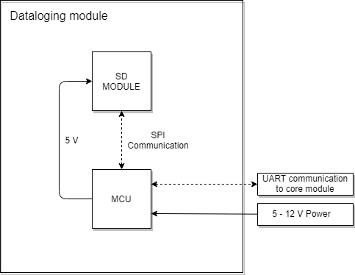

Figure System diagram of datalogger first prototype (Wykerd, 2018)

## Analysis of prototype:

The prototype was analysed using the design requirements and criteria outlined in the research plan to determine how well the prototype succeeds in the engineering goal on page 3.

### Requirements

Since the goal of the first prototype was to test the concept of making a datalogger and to pick out the correct supporting components for the SD card, it does not meet all the requirements of the device.

The device is easily manufacturable, but only in small scale, it would be uneconomical to produce this prototype on a mass scale and the electronics of the device is not permanently attached and can easily be disassembled. This easy disassembly was necessary so that debugging can be done fast, and components can be rewired and/or replaced in a matter of seconds.

The device does not get its power from one power source, this issue is addressed in the next prototype by removing the Arduino entirely and opting for a standalone Atmel MCU.

The device is large and weighs a lot. It is also very expensive, it costs R355. The full breakdown of the project cost is available in Appendix A for the total project cost

The device does for fill-in logging data in a common file format, which is the main requirement of the device.

### Criteria

Table 6 Analysis of first prototype of datalogger to design criteria:

|  |  |  |
| --- | --- | --- |
| Criterion | How well does the device meet the criterion? | Suggested improvements that can be made: |
| The device should draw a low current to prolong the battery life. | The device is powered via the USB of the computer. It does not use a battery as its primary energy source. The device shouldn’t draw more than 20 mA while not writing, but it can draw up to 200 mA during writing depending on the type of SD card used. | This issue can be eliminated by getting rid of the Arduino and using a standalone MCU instead and using the internal oscillator of the MCU. There should also be a way to turn of the module if it is not in use. |
| The device should have a small form factor | The device has a footprint of 25 cm * 12.5 cm * 3 cm. It meets the criterion very poorly. | The device’s size can be dramatically reduced by placing all the components on a single PCB. |
| The device should be user-friendly. | The device’s software is very simple, all it does is relay the data sent from the core module onto the SD card and thus the software is very effective.  The hardware, however, is not at all user-friendly. The goal of this prototype was not to make a product for the end user, but rather to test the components and software | At this moment no improvements can be made to make the device more user-friendly on the software side. The device can be physically made more user-friendly by making the device smaller and self-contained (no computer required). |
| The environmental impact should be kept low | All the components used in this prototype is RoHS compliant and is thus free of certain hazardous substances such as lead. | Fewer components can be used to decrease steps in production that create hazardous by-products (like soldering) |
| Cost should be as low as possible | The prototype cost R355.00 to make. | The cost can be minimized by creating a custom PCB with only the required components (no Arduino or breakout boards only the components that are essential for the device to function) on it. |
| Repair and upgradability | The device can easily be repaired and upgraded as it is built on a breadboard. | No improvements can be thought of at this point |

# **Second prototype of Datalogging module:**

## Introduction

This prototype will use the results obtained in the previous prototype of the datalogging module to create a fully functional, self-contained datalogging module to be used with the core GSM GPS Tracking module.

As with the final prototype of the core module, the datalogger will be contained on a single double layered PCB designed from scratch using the chips’ datasheets as a reference during the components choosing and design stage. The reason for creating a custom PCB is so that the device can be easily manufactured as PCB fabrication is a very fast process.

The prototype will make use of no off the shelf components which should lead to a steep drop in price per unit. Only the SD card will be an off the shelf component and possibly the battery. All of the IC’s, resistors and capacitors will have SMT packages, because these components are much smaller than their through-hole counterparts and these types of components are the most common type components used in factories making the device easier to be manufactured in bulk in factories by pick and place machines. All the components can be purchased directly from the manufactures reducing cost drastically.

A case will also be designed to house the device. The case will offer a way for the core module to mount onto it.

## Choosing the Main Components

There was decided on using the following components in the final prototype design:

For the MCU, once again an ATMEGA328P-AU was chosen, this MCU was chosen instead of a smaller one like say an ATTINY as it has enough ram to run the software required. The software requires 1046 bytes of SRAM to run, thus the 2kB of ram of the 328p is perfect for this task. It also uses a TQFP SMT package.

There was also decided to add a USB-to-TTL converter to allow the user to update the software of the core module. This will make the user-experience easier as the user can update to an SD version of the software without requiring an external programmer. For the converter IC, there was decided on using FTDI FT232RL chip since is a very popular USB-to-TTL converter IC and is well documented online. This will make the design phase much easier. It also has an SMT package for easy mass production.

Lastly, the device also required a battery and means to charge it. For this purpose, there was decided on using a 18650 Li-Ion battery cell as it has a voltage output of 3.7 volt, which is within the voltage range of the core module. To manage the charging of the battery, the MCP73831 Single-Cell Li-Ion Charge Management Controller was chosen due to its reasonable charge current of 500mA allowing the battery to be charged safely. It also came in a SOT-23-5 SMT package that has a small footprint.

## Breakdown of Schematic

The schematic for this prototype was created once again in EasyEDA a free online CAD software for schematic and PCB layout creation.

The full schematic can be found in Appendix I.

All resistors, MLCCs (Multi-Layer Ceramic Capacitors) and Tantalum capacitors are 0608 packages.

### The Power Management Circuit

The Charging Circuit was designed using the MCP73831T Datasheet listed in the references and added in the journal. Below is an image of the section.

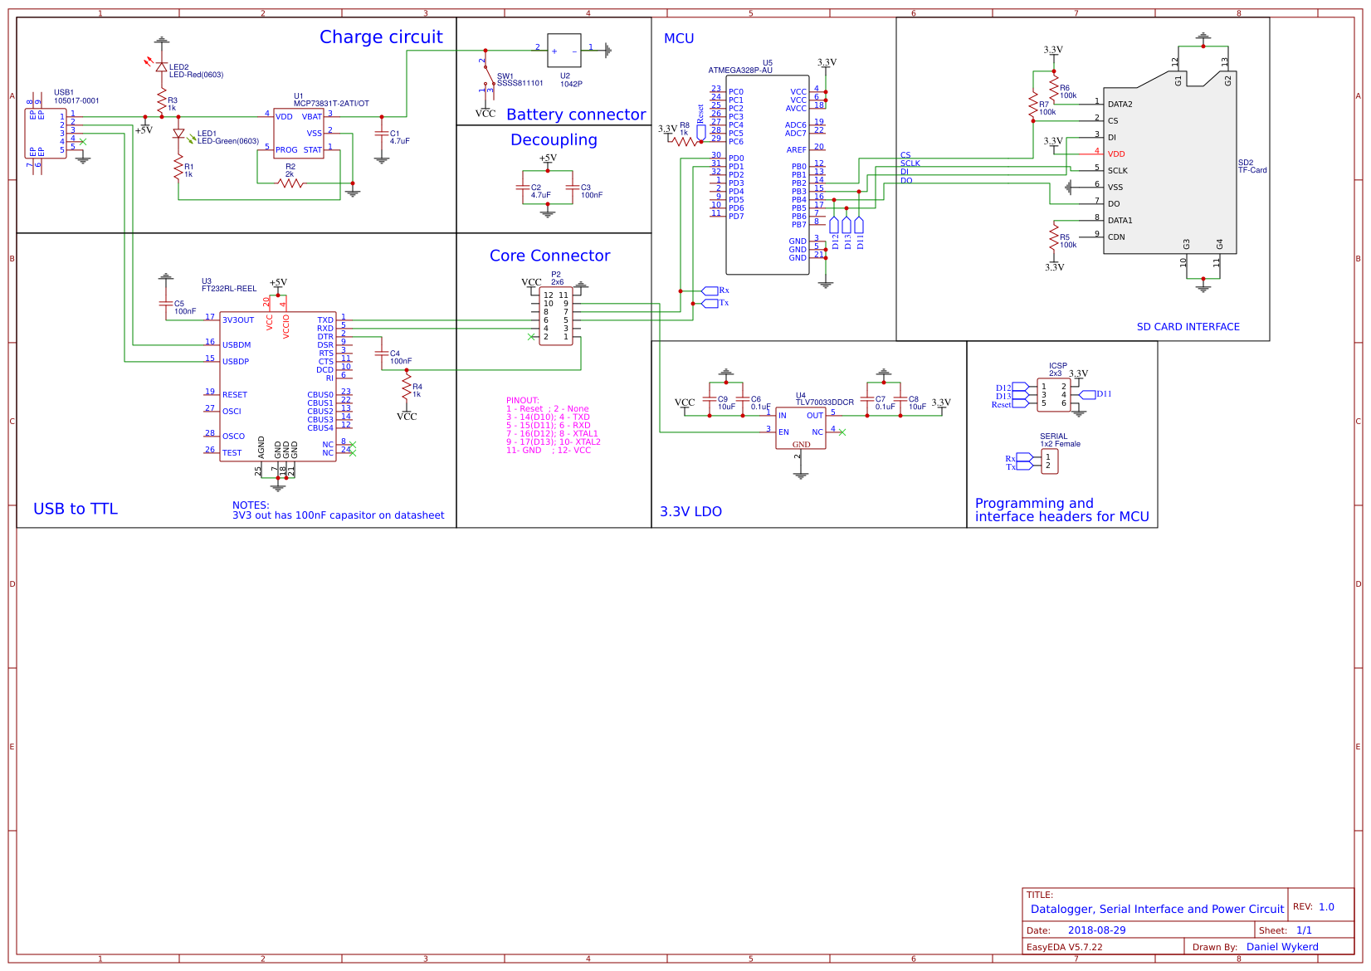

Figure Power Management section of Schematic (Wykerd, 2018)

For the USB port, the Molex 105017-0001 Micro-USB B Receptacle, Surface Mount Connector was chosen due to its availability.

C2: Decoupling Capacitor – smoothens out low-frequency noise on 5v input voltage.

C3: Decoupling Capacitor – smoothens out high-frequency noise on 5v input voltage.

The LED’s give the user a visual indicator of the process of the battery charging. LED1 indicates that the Li-Ion battery is charging and LED2 indicates that the device is connected via USB or is powered on.

C1: Decoupling capacitor – smoothens low-frequency noise on the VBAT pin of the IC that charges the battery.

1042P: SMT Single cell 18650 battery holder.

MCP73831T: Single Cell, Li-Ion/Li-Polymer Charge Management Controller. Charges the Li-Ion battery.

SW1: SPDT or SPST SMT switch used to toggle the power to the MCU and Core module.

R2: Program resistor – sets the charge current of the charge IC, opt for 3.3KOhm instead of 2KOhm for computer USB support. 2KOhm will let the IC charge at 500mA and 3.3KOhm at 303mA, which is more suitable for PC USB ports that can only output 500mA max.

R1, R3: Current limiting resistors – DO NOT USE VALUES INDICATED! Values should be calculated according to the LED rating. For 10mA LED’s use 470 Ohm resistors.

### The USB-to-TTL and Core Interface Circuit

The USB-to-TLL circuit was designed around the FTDI FT232RL IC, which datasheet was used as reference during the design and can be found in the references or journal of the project. Below is a breakdown of this section of the circuit:



Figure USB-to-TTL section of schematic (Wykerd, 2018)

C5: Required for internal 3.3V LDO of IC (U3).

R4: Pull-up resistor for Core module’s MCU, added due to inconsistencies in MCU of the core module.

The FTDI IC converts the data of the USB to UART allowing the user to program the core module by simply plugging it into a computer with USB.

### The SD Card Datalogger

The datalogging circuit allows for one-way storage to the SD Card. Data can be written by the core module but cannot be read with the code flashed to the MCU.



U4 (LDO): The SD card requires 3.3V logic, thus it is simpler to run the whole circuit from 3.3V including the MCU. The LDO only outputs power (and the circuit will only work) if I/O pin 9 (D13 or 17 of MCU) of the core module is pulled to high. This is done to preserve battery life. This is done within the code of the MCU with the digitalWrite(13, HIGH) procedure.

U5 (ATMEGA328P-AU): The MCU has the SD Datalogging code available in Appendix G flashed onto the IC. This IC is in control of the SD card and receives the data to be printed to the file on the SD card via the hardware serial pin receive pin (30/PD0). It is connected to I/O pin 7 (D12 of MCU) of the core module, thus in the software of the core module developers can print any data via software serial from this pin to be logged.

The ICSP and SERIAL headers are used to program the MCU.

R8, R6, R7, R5: Pullup resistors.

C6, C7, C8, C9: Decoupling capacitors.

## Bill of Components (BOM)

Table 7 BOM of datalogger second prototype



The total cost of the project is available in Appendix A.

## PCB Layout

The PCB layout was designed in EasyEDA a free web-based CAD software for creating schematics and PCBs. All resistors and capacitors are 0603 packages.

Before the final PCB layout, there were several failed layouts, which can be found in the journal.

Below is a figure of the top PCB layer:

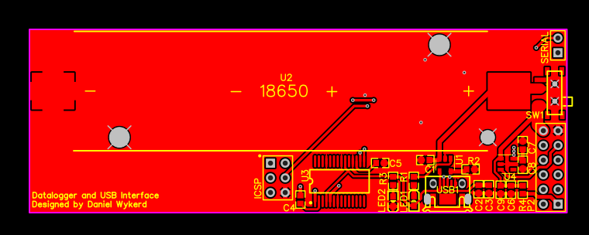

Figure Top Layer PCB Layout (Wykerd, 2018)

All the power and USB interface circuitry are located on the top layer of the PCB.

Below is a figure of the bottom layer of the PCB:

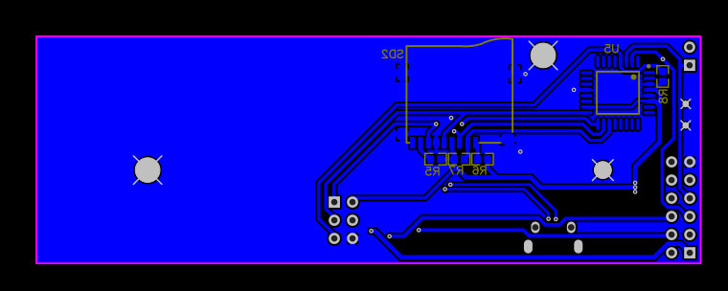

Figure Bottom Layer PCB Layout (Wykerd, 2018)

The datalogging circuitry is located on the bottom layer of the PCB.

Assembly drawing:

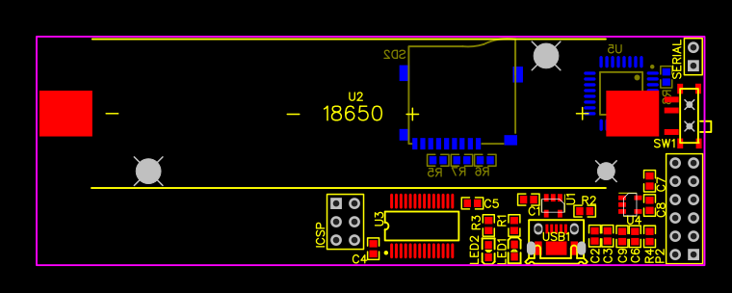

Figure Assembly Layout of datalogger (Wykerd, 2018)

## System Diagram

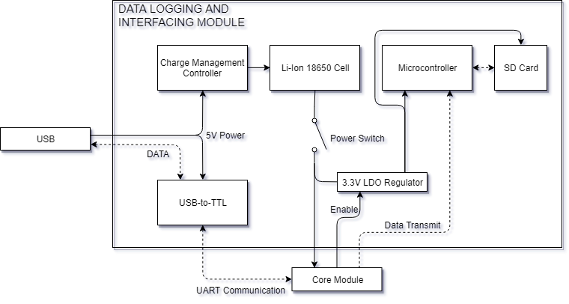

Figure System diagram of second datalogging prototype (Wykerd, 2018)

## Assembly

Assembly required special equipment and knowledge of SMT soldering. Thus, Danie Ludick and Johann Erasmus were asked to solder the boards. Both boards worked flawlessly. Below are images of the assembled boards:

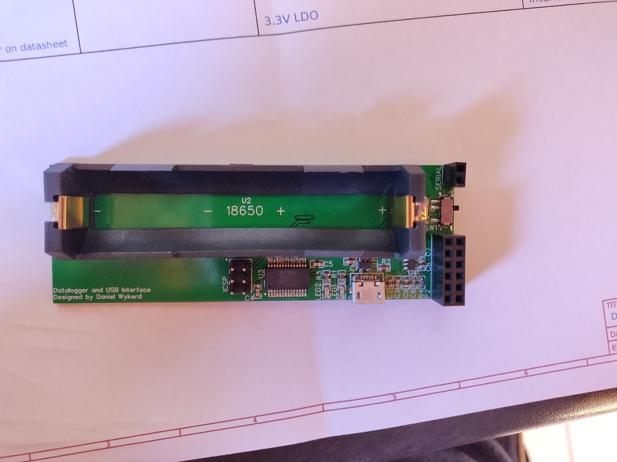

Figure Complete assembled PCB of datalogger (Wykerd, 2018)

After the boards were soldered, the Arduino bootloader had to be burned to the ATMega328p, this was done using the ICSP header and another Arduino acting as an ISP. Below is an image of this step of the assembly.

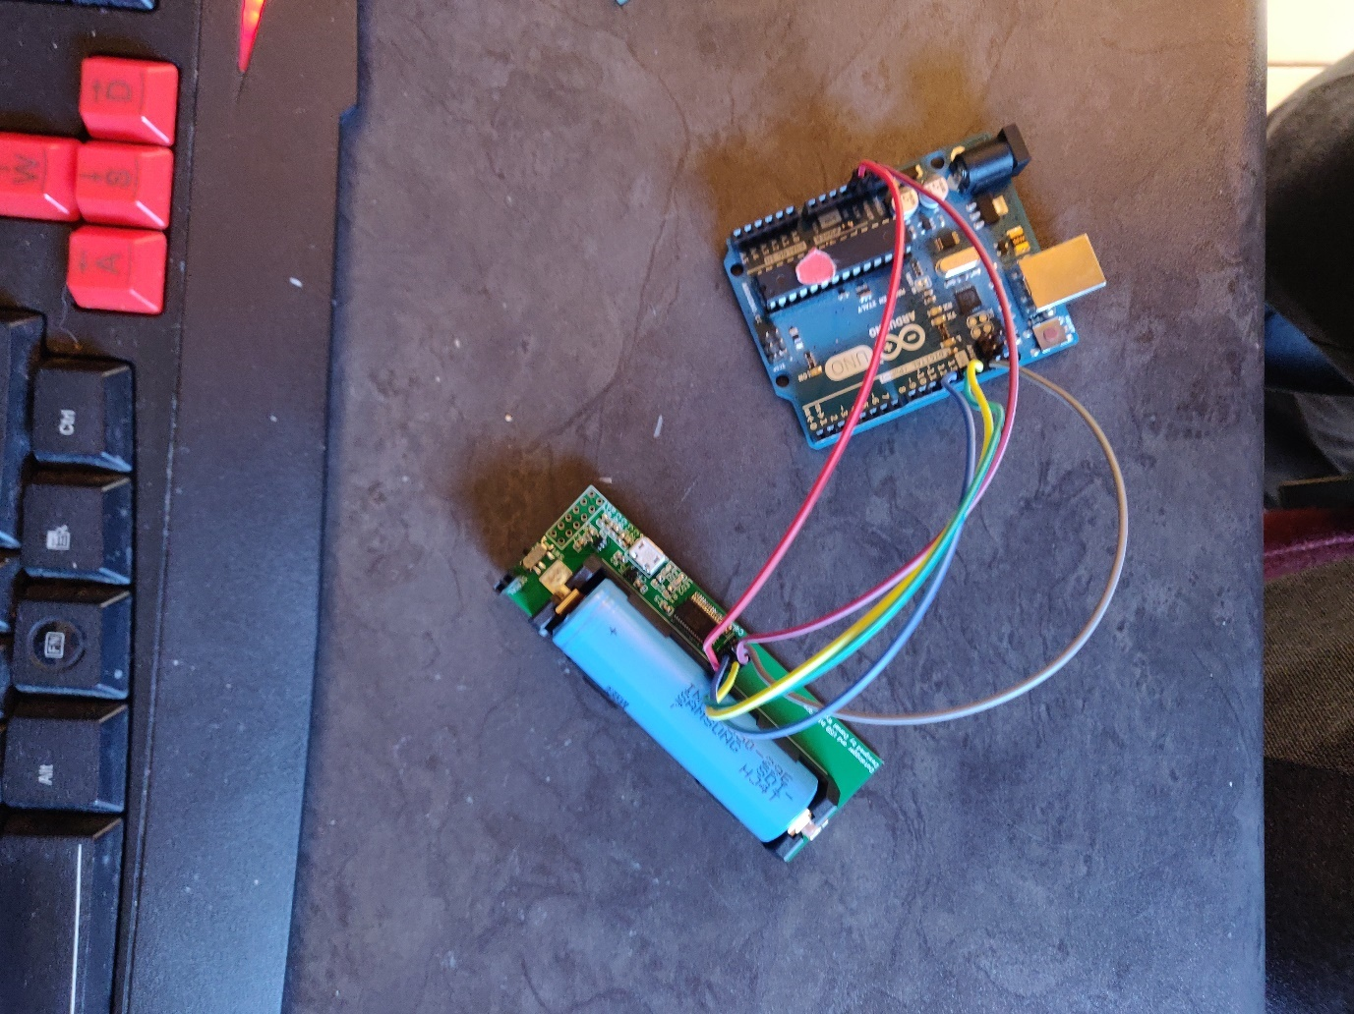

Figure Burning bootloader to datalogger (Wykerd, 2018)

After the bootloader is burned to the ATMega it can be programmed via the serial headers using a USB-to-TTL converter. In this case, an Arduino was used as the converter. The SD Card Datalogging code found in Appendix G was uploaded to the board. Below is an image of this step:

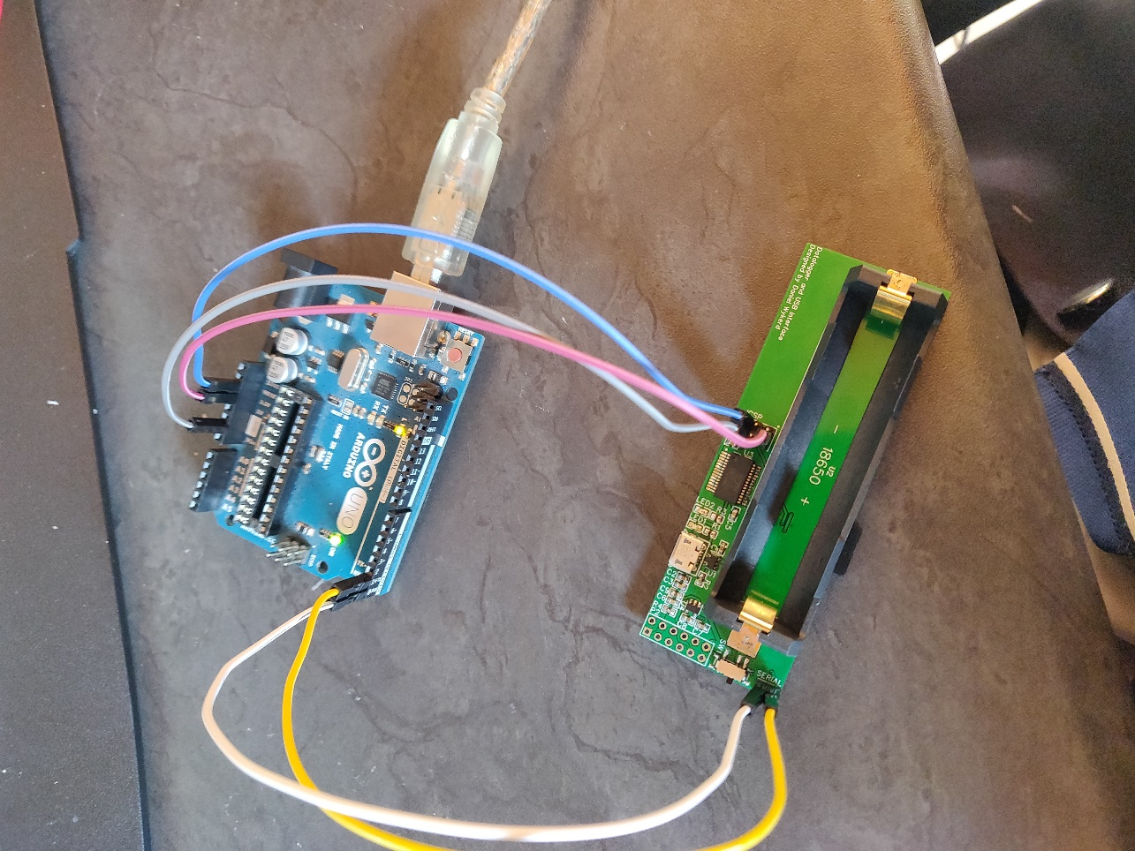

Figure Programming the datalogger's MCU (Wykerd, 2018)

## Software

The software of the datalogger is the same as the software used in in the first prototype of the datalogger and is available in Appendix H. The core module’s software is also the same, but it has a few added lines of code that allow for more power efficiency as it only turns on the LDO that supplies the datalogger of power when it is used. The completed code is in Appendix F.

## Usage of the Device

This device/module is designed to be used with the core GSM GPS Tracking module. It is designed to be as user-friendly as possible.

The core module connects to the device and communicates via the UART protocol to the MCU onboard the device to log data to the SD card. The device also provides the core module of power and provides the user of a way to update the software of the device via USB.

To use this device the software of the core module needs to be updated/changed to an SD version (refer to Appendix G for naming scheme). This will add the ‘record’ command to the module that will allow the user to log the GPS coordinates to the SD card. See the page 41 for an explanation of the ‘record’ command.

Below is an image of the device in working order with the core module connected to it:

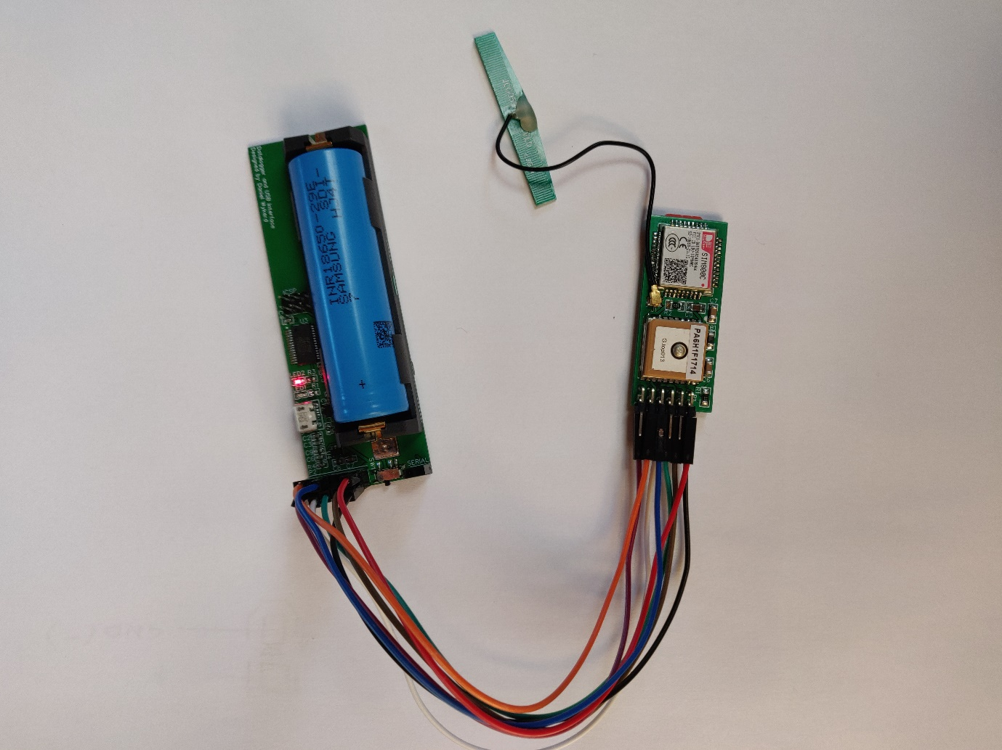

Figure Datalogger connected to core module (Wykerd, 2018)

## Analysis of results

The prototype was analysed using the design requirements and criteria outlined in the research plan to determine how well the prototype succeeds in the engineering goal on page 3.

### Requirements

The device meets all the requirements set out in the research plan.

The device is easily manufacturable because the device is contained on a single multi-layered PCB thus the device can be easily manufactured as PCB fabrication is a very fast process. It also uses SMT components which can be placed a fast by pick and place machines increasing production speed and lowering cost as less people are involved in production.

There is no off the shelf components used in the build resulting in a steep drop in the price per unit (especially if the device is made in large quantities where the components are brought in bulk).

The device uses a common file format called GPX to log data and can be viewed on any GPX viewer like Google Earth or Strava (a fitness app).

The device is extremely light weighing 22g without the battery and 68g with the battery. The device provides power for the core module and gets its power from the same power source, an 18650 Li-Ion cell.

The device cost extremely little to make and cost less than the core module. The device costed around R133.34 (prices were originally in dollar and were converted at R14.15 per dollar). This price can reduced in mass production.

### Criteria

Table 8 Analysis of second prototype of datalogger to design criteria

|  |  |  |
| --- | --- | --- |
| Criterion | How well does the device meet the criterion? | Suggested improvements that can be made: |
| The device should draw a low current to prolong the battery life. | The device uses no power if not recording and uses around 4-200mA while writing/logging data to the SD card. The current draw varies according to what SD card you use. The USB circuit draws between 308mA and 318mA. | At this point no improvements can be made to reduce current draw of the SD Datalogging module. As the current is drawn by the SD card and not the module. |
| The device should have a small form factor | The device has a footprint of 93mm * 32mm cm * 20mm. It meets the criterion quite well | The device’s size can be reduced by using a smaller battery and the PCB is designed in such a way that this change can be made easily. |
| The device should be user-friendly. | The device’s software is very simple, all it does is relay the data sent from the core module onto the SD card and thus the software is very effective.  The hardware is also very user friendly, it allows the user to simply plugin their existing core module and update the code via the included USB to use the secondary module. | Software can be written to make the software update easier as at this point it relies on the user using the Arduino IDE to upload the new code via the USB. This can be done by making software that programmatically upload the code through a push of a button. |
| The environmental impact should be kept low | The prototype uses lead solder which is a hazardous substance. | Opt for lead free solder in later production. |
| Cost should be as low as possible | The prototype cost R133.34 to make. | This cost will reduce if components are brought in bulk. |
| Repair and upgradability | The device uses SMT components which is not easily replaceable. The battery is removable, and software is upgradable. | No improvements can be thought of at this point |

# **Discussion**

A lot of results has been obtained in this project. The discussion will point out patterns in the results and explain it. Both devices’ (core and datalogger) limitations will also be discussed.

## Core module:

Each revision (prototype) of the core device/module met the design requirements and criteria better than its predecessor for the following reasons:

With each prototype, a significant decrease in the size of the core device occurred. This is because as later prototypes were developed, the components used for testing the core device became unnecessary and thus more of the components were omitted with each design revision leading to a smaller form factor.

The current draw of the device also decreased with each prototype as the unnecessary power-hungry components were removed.

The core device has several limitations. The first is that the device can only get a GPS fix if it is outside. If the device is switched on inside a building it will not get a GPS fix unless it is placed near a window or somewhere with a clear line of sight with the GPS satellites. The device will function indoors if an initial GPS fix was gained outside.

The other limitation is the battery life that can be improved in later software updates by reimplementing the GPS off feature to preserve power. Another possible solution that could be researched is to add an off switch to the battery module.

Further research that can be done and improvements that can be made in the future includes designing some more supporting modules like battery modules or modules that allow attachment of the device to objects. Another version of the software could be created that constantly streams the device’s location to a data server like a MySQL server, allowing the user to view a log of where the device was using the web. The device already supports uploading to the internet and has 2G network support thus this feature can easily be added in the future. The GSM antenna can be put onto the PCB making the assembly process easier. The MCU can be upgraded to a more powerful one allowing for more complex interfacing with more modules, as the current MCU is quite limited in resources.

## Datalogging, Power and USB interfacing module:

The datalogging module, designed to be used with the core GPS GSM module, met the design criteria and requirements better with each revision (prototype).

This is because the first prototype was merely designed to test the concepts and components required to make a datalogger.

This massive improvements in size from the first prototype to the second can be because the second prototype does not make use of off the shelf components or any breakout or development boards, which the first prototype made heavy use of. All the unnecessary components were also removed in the second design of the datalogger also leading to a reduction in size.

This secondary/slave module proves how modular the core module really is and how easy it can be to add additional functionality to the tracker without buying an entirely new tracker, but instead adding more inexpensive to existing hardware.

One of the limitations of this device is that it does not give way to read any data from the SD card. This is not a massive issue but limits additional software that can be written by a developer for the core and SD module, thus further research can be done to create a simple communication language/protocol to retrieve data from the SD card to the datalogger’s MCU and then to the core module’s MCU by allowing the core module to send simple commands to the MCU of the datalogger instructing whether to read or write data. This will not require any new hardware but rather a simple software update to the datalogging module’s MCU.

# **Conclusion**

The Modular GSM GPS Module designed and manufactured in this project meets the requirements and criteria set out in the research plan of this project exceptionally well.

Thanks to the fact that a custom PCB was created using industry standard production techniques the module is easily manufacturable, costs only R293.47 to make and does not require a subscription to a third party. The PCB is accompanied by a great case that makes the core device modular, meaning features can easily be added if other companies make modules for the device that is compatible with the PCB’s pinout and case design. The PCB and case were designed in such a way that it is easy to create these modules. It shouldn’t take a company to long to produce its own module.

The core device draws a low current of around 50 mA and can last over for 48 hours on a 2350 mAh battery (NOTE: These results are inaccurate as the batteries were old and only one experiment was done). According to all these results obtained, it is clear that the core device/module created meets the engineering goal of this project.

The modular nature is proven by the datalogging module. This secondary/slave module proves how modular the core module really is and how easy it can be to add additional functionality to the tracker without buying an entirely new tracker, but instead adding more inexpensive to existing hardware, which is part of the engineering goal of this project and further proves that the core module meets its goal.

The datalogging module designed and manufactured in this project also meets the requirements and criteria set out in the research plan of this project well.

It is also made using industry standard production techniques making it easily manufacturable and it keeps the cost low, it only costs R133,34 to make. The module is very user-friendly and works seamlessly with the core device as it requires no additional power source, it adds minimal weight and logs the GPS data to a commonly used file format. Thus, the secondary datalogging module also meets the engineering goal of this project.

Therefore, in conclusion, the project has completely achieved its engineering goal.

# **Bibliography**

Adafruit Industries, 2012. *Adafruit Ultimate GPS Arduino Wiring.* [Online]   
Available at: https://learn.adafruit.com/adafruit-ultimate-gps/arduino-wiring  
[Accessed 20 01 2018].

Adafruit Industries, 2012. *Learn Adafruit Ultimate GPS Downloads.* [Online]   
Available at: https://learn.adafruit.com/adafruit-ultimate-gps/downloads  
[Accessed 5 5 2018].

Arduino, n.d.. *ArduinoToBreadboard.* [Online]   
Available at: https://www.arduino.cc/en/Tutorial/ArduinoToBreadboard  
[Accessed 13 04 2018].

Arduino, n.d.. *Reference GSM Library.* [Online]   
Available at: https://www.arduino.cc/en/Reference/GSM  
[Accessed 06 02 2018].

Arduino, n.d.. *Standalone Atmega.* [Online]   
Available at: https://www.arduino.cc/en/uploads/Hacking/Atmega168PinMap2.png  
[Accessed 13 4 2018].

FTDI Chip, n.d. *FT232R USB UART IC Datasheet.* [Online]   
Available at: https://www.ftdichip.com/Support/Documents/DataSheets/ICs/DS_FT232R.pdf  
[Accessed 25 09 2018].

Hart, M., 2013. *TinyGPS++ Source Code.* [Online]   
Available at: https://github.com/mikalhart/TinyGPSPlus/blob/master/src/TinyGPS%2B%2B.h  
[Accessed 2018].

Microchip, n.d. *MCP73831/2.* [Online]   
Available at: http://ww1.microchip.com/downloads/en/DeviceDoc/20001984g.pdf  
[Accessed 25 09 2018].

Murata, n.d.. *Chip Ferrite Bead.* [Online]   
Available at: https://www.mouser.co.za/datasheet/2/281/QNFA9105-1130343.pdf  
[Accessed 8 5 2018].

SIMCom Wireless Solutions, 2017. *SIM800C Hardware Design.* [Online]   
Available at: http://simcom.ee/documents/SIM800C/SIM800C_Hardware_Design_V1.05.pdf  
[Accessed 8 5 2018].

SIMCom, 2015. *SIM800H&SIM800L Hardware Design.* [Online]   
Available at: http://simcom.ee/documents/SIM800H/SIM800H%26SIM800L_Hardware%20Design_V2.02.pdf  
[Accessed 8 5 2018].

SIMCom, 2016. *SIM808 Hardware Design.* [Online]   
Available at: http://simcom.ee/documents/SIM808/SIM808_Hardware%20Design_V1.03.pdf  
[Accessed 5 5 2018].

SIMCom, n.d. *SIM800 Series_AT Command.* [Online]   
Available at: https://www.elecrow.com/download/SIM800%20Series_AT%20Command%20Manual_V1.09.pdf  
[Accessed 23 09 2018].

South African Police Service, n.d.. *SAPS Crime Statistics.* [Online]   
Available at: https://www.saps.gov.za/services/crimestats.php  
[Accessed 28 April 2018].

Stats SA, 2017. *Statistical Release P0341.* [Online]   
Available at: https://www.statssa.gov.za/publications/P0341/P03412016.pdf  
[Accessed 28 April 2018].

Topograpix, n.d. *GPX 1.1 Schema Documentation.* [Online]   
Available at: http://www.topografix.com/GPX/1/1/  
[Accessed 23 09 2018].

TrackTheWorld, n.d.. *TRACKERS: MULTI-PURPOSE.* [Online]   
Available at: http://www.trackingtheworld.com/products/multipurpose.php  
[Accessed 28 April 2018].

Wikipedia, 2018. *Global Positioning System.* [Online]   
Available at: https://en.wikipedia.org/wiki/Global_Positioning_System  
[Accessed 06 May 2018].

Wikipedia, 2018. *Microcontroller.* [Online]   
Available at: https://en.wikipedia.org/wiki/Microcontroller  
[Accessed 6 May 2018].

Wykerd, D., 2018. *All images of assembly of datalogger prototypes.* [Art].

Wykerd, D., 2018. *Assembly of first prototype.* [Art].

Wykerd, D., 2018. *Breadboard layout of first prototype.* [Art].

Wykerd, D., 2018. *Case designs.* [Art].

Wykerd, D., 2018. *Case designs (all).* [Art].

Wykerd, D., 2018. *Example of the serial output.* [Art].

Wykerd, D., 2018. *Format of #Location.* [Art].

Wykerd, D., 2018. *Image of first prototype components.* [Art].

Wykerd, D., 2018. *PCB Layouts (all).* [Art].

Wykerd, D., 2018. *Photo of second prototype assembly.* [Art].

Wykerd, D., 2018. *Photos of all datalogger prototypes.* [Art].

Wykerd, D., 2018. *Photos of final prototype.* [Art].

Wykerd, D., 2018. *Schematic and breadboard layout of second project.* [Art].

Wykerd, D., 2018. *Schematic of datalogger (all).* [Art].

Wykerd, D., 2018. *Schematic of first prototype.* [Art].

Wykerd, D., 2018. *Schematics of core module third prototype.* [Art].

Wykerd, D., 2018. *System diagrams.* [Art].

Wykerd, D., 2018. *Test Wiring of SIM800L.* [Art].

# **Acknowledgments**

Thanks to Rochelle and Malan Wykerd for funding this project and to everyone who sponsored money for the datalogging module’s final prototype.

Thanks, Johann Erasmus for soldering the first attempt at assembling the final prototype, helping with the debugging of the final prototype of the core module’s first attempt, and soldering one of the datalogging modules.

Thanks to Dr. Danie Ludick (PhD) for organizing with the University of Stellenbosch to populate the final prototype of the core module and datalogging module, reading through my designs and helping to debug the first attempt to assemble the final prototype of the core.

Thanks to Grant Parkes for giving advice regarding the case design and for arranging the manufacturing of the case.

Unpopulated PCBs fabricated by JLCPCB.

# **Appendix A**

Table 9 Total cost of project



# **Appendix B**

THE CODE WITH THE GPS OFF FEATURE IS ON THE NEXT TWO PAGES: (Dev Ver 1A)

# **Appendix C**

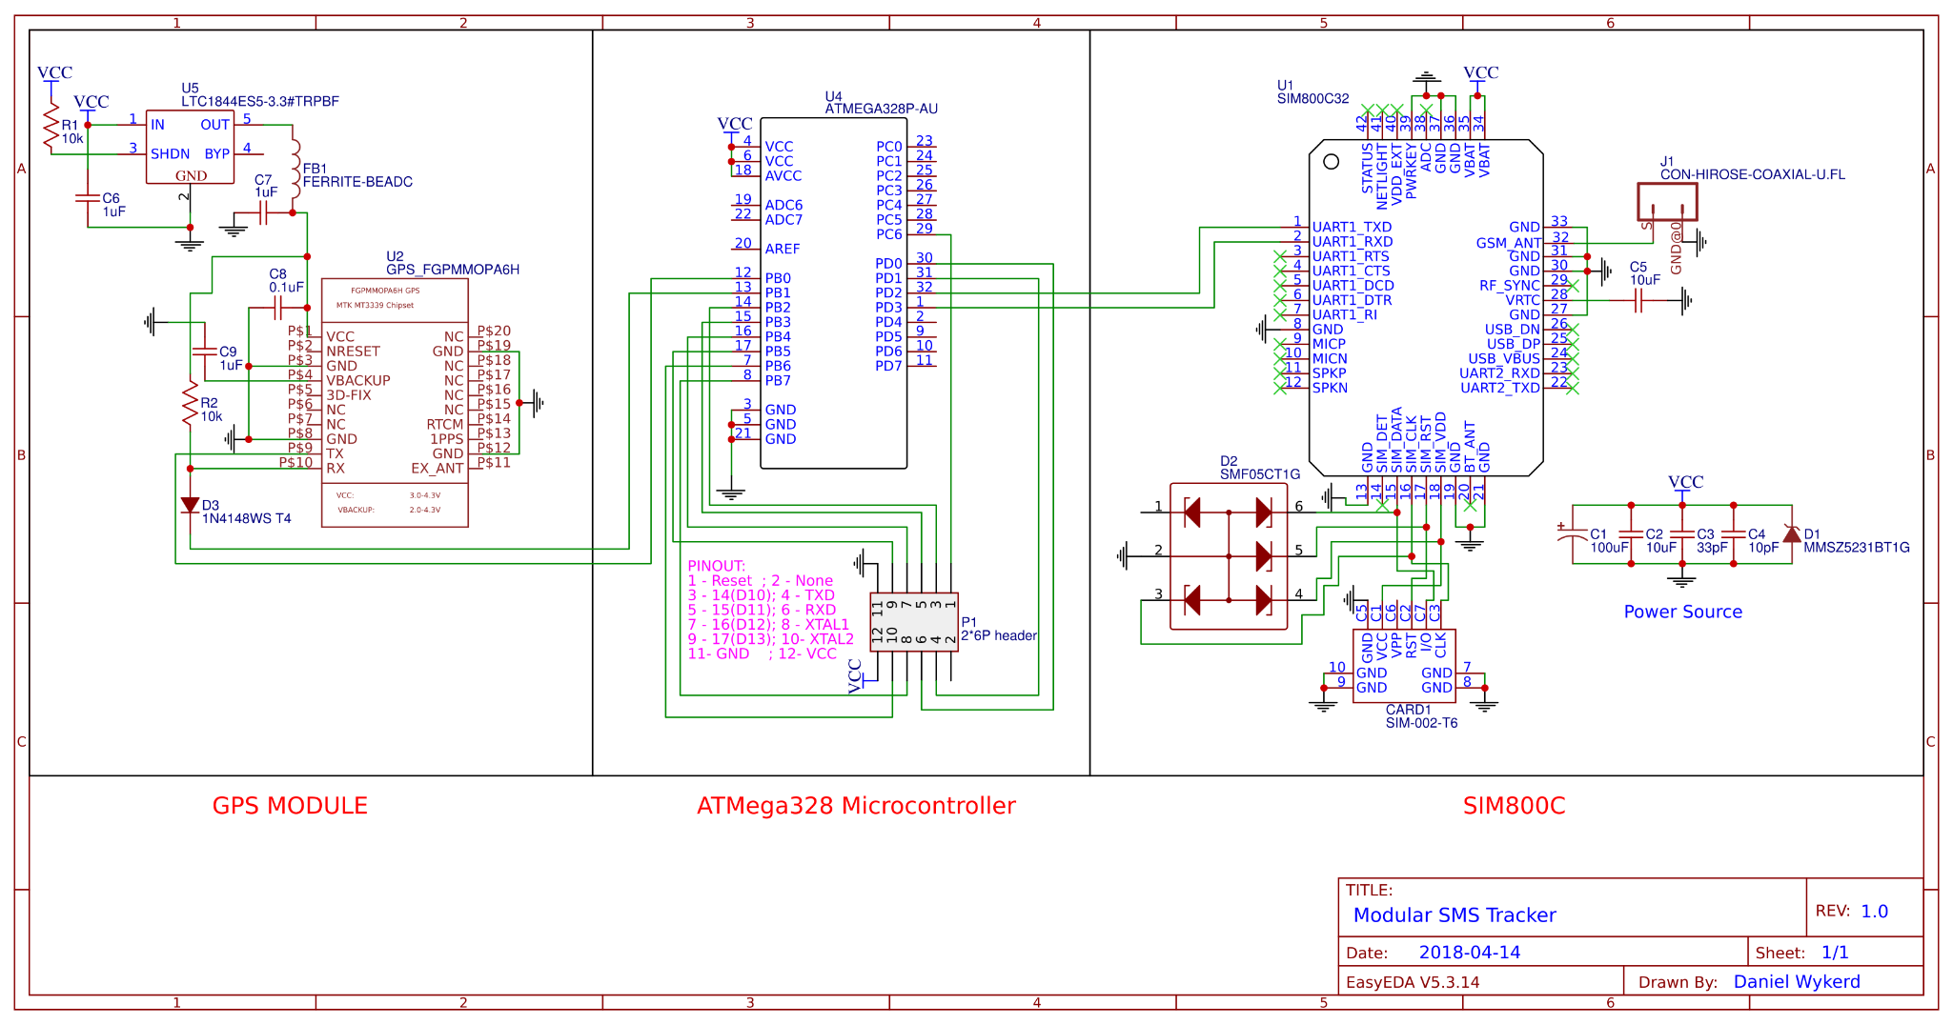

# **Appendix D**

THE CODE WITHOUT THE GPS OFF FEATURE IS ON THE NEXT TWO PAGES: (Dev Ver 1.1A)

# **Appendix E**

THE DRAWING OF THE CASE IS ON THE NEXT PAGE

# **Appendix F**

THE CODE FOR THE GPS GSM (core) MODULE WITH SD MODULE IS ON THE NEXT PAGE: (DEV BUILD 3SD)

# **Appendix G**

Naming scheme for core module firmware:

Version format: <Release Status> Build/Ver <Version number><Iteration>

<Release Status>

Dev – The code is still in development and has many bugs

Alpha – The code is still in development and has bugs

Beta – The code is near completion and has small bugs

Stable – The code is stable and works well

<Version Number>

The version of the firmware

<Iteration>

A – Firmware for use with core module only (standalone firmware)

SD – Firmware for use with SD datalogging module.

*More iterations can be added as more secondary modules are made.

Example:

Software with version name: **Dev Build 3SD**

From the name of this software one can assume that the software is still in development and is buggy, it is the 3rd version of the software and it is for use with the SD datalogging module.

# **Appendix H**

THE CODE FOR THE MCU OF THE DATALOGGER MODULE IS ON THE NEXT PAGE: (SD_GPS_MODULE_REV1)

# **Appendix I**

THE SCHEMATIC OF THE DATALOGGER SECOND PROTOTYPE IS ON THE NEXT PAGE: